\_\_\_\_\_\_\_\_\_\_\_\_\_\_\_\_\_\_\_\_\_\_\_\_\_\_\_\_\_\_\_\_\_\_\_\_ \_\_\_\_\_\_\_\_\_\_\_\_\_\_\_\_\_\_\_\_\_\_\_\_\_\_\_\_\_\_\_\_\_\_\_\_

\_\_\_\_\_\_\_\_\_\_\_\_\_\_\_\_\_\_\_\_\_\_\_\_\_\_\_\_\_\_\_\_\_\_\_\_ \_\_\_\_\_\_\_\_\_\_\_\_\_\_\_\_\_\_\_\_\_\_\_\_\_\_\_\_\_\_\_\_\_\_\_\_

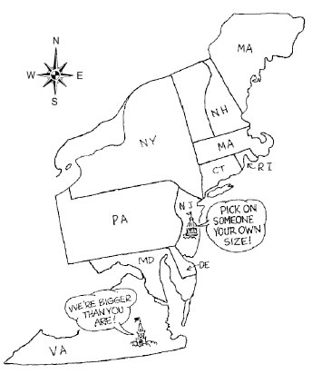

Use this reading to complete the notes section:

Delegates from the states met at the Constitutional Convention to vote and ratify (approve) a new form of government under what we call the Constitution. The ratification of the Constitution led to the creation of a stronger, federal government. In order to do so, though, they had to approve a series of compromises. No compromise was bigger than the Great Compromise that sought to placate both large and small states. Small states wanted equal representation in Congress with each state getting the same number of representatives in Congress no matter how big or small the state population was. A plan, the New Jersey Plan, was submitted that supported this idea. Large states opposed the idea of equal representation, however, because they believed that the bigger the population of the state, the more representatives they should received. According to the Virginia Plan, large states wanted representation in Congress to be based on a state’s population. The Virginia Plan also called for a two-house (bicameral) Congress. The Great Compromise was a compromise between these two plans. It led to a two-house Congress where one house, the Senate, has equal representation for each state (two Senators per state) and the other house, the House of Representatives, bases the number of representatives for each states on the state’s population.

Once this was decided, the states began to argue over how slaves should be counted when deciding a state’s population. Southern states wanted each slave to be counted when deciding how large a state’s population was. Northern states protested that this gave the southern states an unfair advantage when deciding representation for the House of Representatives. Northern states also believed that because slaves were not citizens and could not vote, they should not be counted towards representation. The 3/5ths Compromise was a compromise between the northern and southern states that stated that each slave would be counted as 3/5ths of a person. You could also look at it as every 3 out of 5 slaves would be counted when adding up a state’s population.

MCMP00302_0000[1]MCMP00342_0000[1]

How are these plans the same?

Virginia Plan

New Jersey Plan

In the summer heat, the delegates at the Constitutional Convention argued day after day over the great issues at stake. Finally, Roger Sherman of Connecticut worked out a \_\_\_\_\_\_\_\_\_\_\_\_\_\_\_\_\_\_\_\_\_\_ that he hoped would satisfy both the large states and small states.

***Define Compromise (noun):***

On July 16, 1787, delegates narrowly voted to \_\_\_\_\_\_\_\_\_\_\_\_\_\_ Sherman’s proposals, which came to be known as the \_\_\_\_\_\_\_\_\_\_\_\_\_ \_\_\_\_\_\_\_\_\_\_\_\_\_\_\_\_\_\_\_\_\_\_\_.

Define the “Great Compromise”:

The Great Compromise was a vital step in creating a new \_\_\_\_\_\_\_\_\_\_\_\_\_\_\_\_\_\_\_\_\_. Now, small-state delegates were willing to support a strong \_\_\_\_\_\_\_\_\_\_\_\_\_ government.

Other issues also divided the delegates – none more so than the question of \_\_\_\_\_\_\_\_\_\_\_\_\_\_\_\_. The issue touched off bitter debates between \_\_\_\_\_\_\_\_\_\_\_\_\_\_\_\_\_\_\_\_\_ and \_\_\_\_\_\_\_\_\_\_\_\_\_\_\_\_\_\_\_\_\_\_.

Southern delegates said that enslaved people should be \_\_\_\_\_\_\_\_\_\_\_\_\_\_\_\_\_ in calculating

how many \_\_\_\_\_\_\_\_\_\_\_\_\_\_\_\_\_\_\_\_\_\_\_ a state should have in \_\_\_\_\_\_\_\_\_\_\_\_\_\_\_\_\_. Northern delegates said that because enslaved people could not \_\_\_\_\_\_\_\_\_\_, they should not be \_\_\_\_\_\_\_\_\_\_\_\_\_\_\_ toward a state’s \_\_\_\_\_\_\_\_\_\_\_\_\_\_\_\_\_\_\_\_\_\_\_\_.

Define the “3/5ths Compromise”:

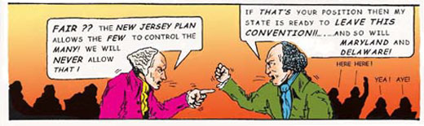

*In the cartoon above, what kind of state does the man on the left come from? How do you know this? What kind of states does the man on the right come from? How do you know this?*

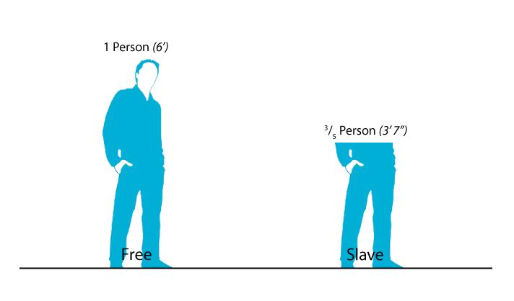

*What does the diagram to the right represent? Explain the rule that it represents.*

MCj03891740000[1]



Explain how the Senate works:

Explain how the House of Representatives works:

How was Roger Sherman’s proposal a COMPROMISE?

MCj03891740000[1]

*Directions: Fill in each thought bubble below to show how the Constitutional Convention came to the Great Compromise. Your thought bubbles should clearly explain 1) what the Virginia Plan wanted, 2) what the New Jersey Plan wanted, 3) why big states and small states disagreed, and 4) how the Great Compromise made each type of state happy.*

