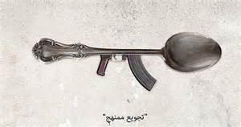

STARVATION

**DISEASES ANIMALS**

WARS

PIGS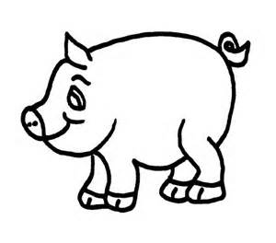

**Columbian Exchange**



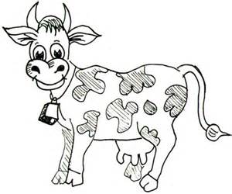

**COWS**

Decrease in the

New World

Indigenous

____________________

Movement of people and goods between Old and New World

Revolutionized food supply

Remade Indian

Culture. (Nomad lifestyle)

**PLANTS/FOOD**

More caloric

Corn

Redistribution of the world’s population

Tomatoes

Potatoes

Forced migration of

_________________

to New World

Better nutrition led to greater population

**PEOPLE**