Recent Supreme Court Cases
(VUS.15a)

Directions

Split into four groups. For each “main idea,” research your group’s case. Summarize the circumstances and legal issues of the case, explaining how it relates to the main idea. Then tell whether you agree or disagree with the Supreme Court’s decision and explain why. (You will be sharing this information with the whole class). Finally, no matter what group you belong to, fill in all of the blanks under main idea #5.

Main Idea #1

The United States Supreme Court protects the individual rights enumerated in the Constitution of the United States.
- Group 1: Engel v. Vitale, 1962
- Group 2: Gideon v. Wainwright, 1963
- Group 3: Miranda v. Arizona, 1966
- Group 4: Tinker v. Des Moines, 1969

Case Name

Summary | Agree or Disagree? Why?

Main Idea #2

The United States Supreme Court has used the 14th Amendment to uphold the equal protection of all Americans under the Constitution.
- Group 1: Brown v. Board of Education, 1954
- Group 2: Heart of Atlanta Motel v. U.S., 1964
- Group 3: Loving v. Virginia, 1967
- Group 4: Obergefell v. Hodges, 2015

Case Name

Summary | Agree or Disagree? Why?

Main Idea #3

The United States Supreme Court identifies a constitutional basis for a right to privacy that is protected from government interference.
- Group 1: Mapp v. Ohio, 1961
- Group 2: Griswold v. Connecticut, 1965
- Group 3: Roe v. Wade, 1973
- Group 4: Riley v. California, 2014

Case Name

Summary | Agree or Disagree? Why?

Main Idea #4

The United States Supreme Court invalidates legislative acts and executive actions that the justices agree exceed the authority granted to government officials by the Constitution of the United States.
- Group 1: New York Times v. U.S., 1971
- Group 2: U.S. v. Nixon, 1974
- Group 3: District of Columbia v. Heller, 2008
- Group 4: Citizens United v. Federal Election Commission, 2010

Case Name

Summary | Agree or Disagree? Why?

Diversity on the Supreme Court

Main Idea #5
The membership of the United States Supreme Court has become more diverse over time to include women and minorities.

Thurgood Marshall  Appointed in 1967 | Sandra Day O’Connor  Appointed in 1981
 | 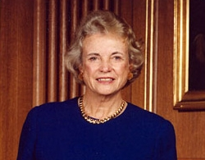
Thurgood Marshall was the first ________-__________ to serve on the Supreme Court. Before his time on the Court, Marshall had established himself as a defender of civil rights through his work as an attorney for the N__________ A_________________ for the A_______________ of C__________ P___________. As a lawyer, he successfully argued for the integration of public schools in the landmark case of ____________ v. _____________ (1954). | Sandra Day O’Connor was the first ____________ to serve on the Supreme Court. She was a moderate who sometimes sided with liberals, sometimes with conservatives, and often provided the “__________” vote when the Court was divided 5 to 4.
Clarence Thomas  Appointed in 1991 | Ruth Bader Ginsburg  Appointed in 1993
 | 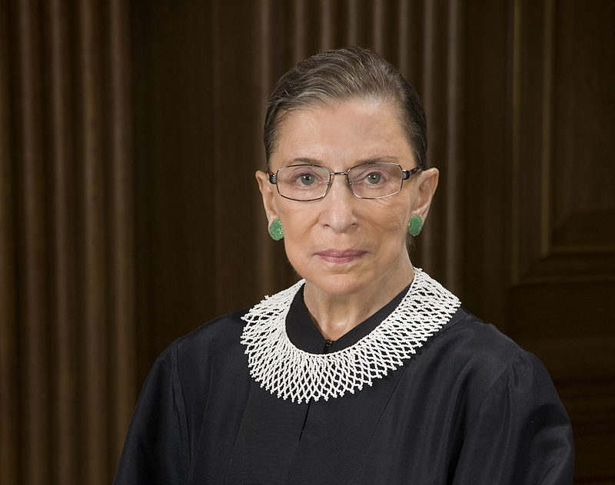
Clarence Thomas is the second __________-________ to serve on the Supreme Court. He is a member of the Court’s conservative block, authoring opinions that have interpreted the ________________ in a strict and literal way. He has been noted for never ______________ during oral arguments before the court. | Ruth Bader Ginsburg is the second ___________ to serve on the Supreme Court. She is a member of the Court’s liberal wing, authoring opinions that have upheld women’s right to obtain an ____________ to terminate unwanted pregnancies. Because of her strongly worded written opinions, she is sometimes known in popular media as “The ______________ R.B.G.”
Sonya Sotomayor  Appointed in 2009 | Elena Kagan  Appointed in 2010
Sonia Sotomayor is the third ___________ to serve on the Supreme Court. Born in the U.S. territory of Puerto Rico, she is also the first _____________ on the Court. | Elena Kagan is the fourth _____________ to serve on the Supreme Court. She is the most recent appointee to the Court, being nominated by President ____________ in 2010.

The Supreme Court Today
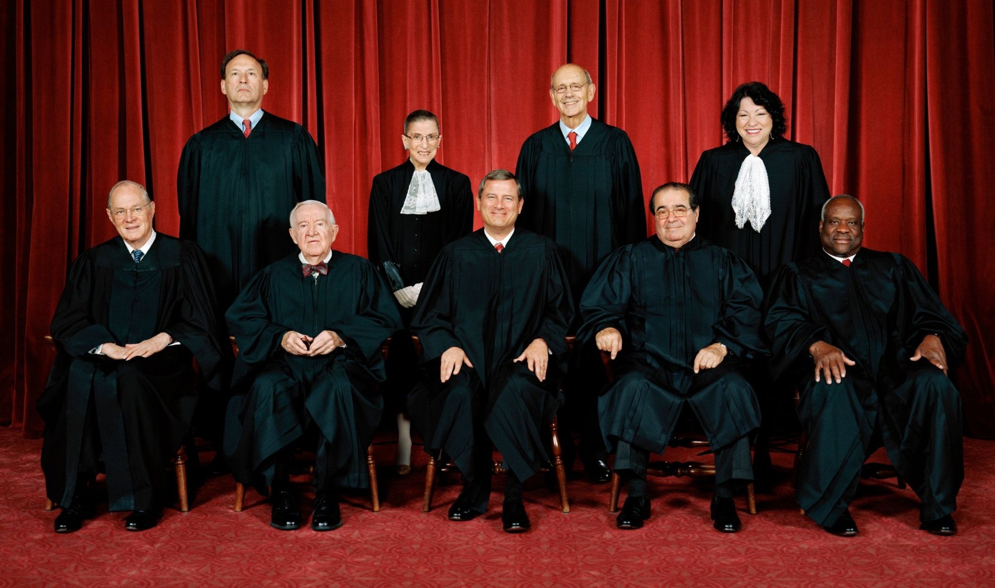
The U.S. Supreme Court under Chief Justice John Roberts, 2010-present

