Reagan Revolution

Reagan and his policies started a revolution in the Republican Party and the way Americans look at the government. Ronald Reagan’s policies had an impact on the relationship between the federal and state governments. The conservative political philosophy of President Reagan prompted a reevaluation of the size and role of government in the economy and society of contemporary America.

Part I: Match the terms by writing the correct term next to the appropriate image in the margins. You will use each term more than once.

Terms:
tax cuts • transfer of responsibilities to state governments • judicial restraint • reduction in the number and scope of government programs and regulations (reduce federal gov’t) • strengthened American military
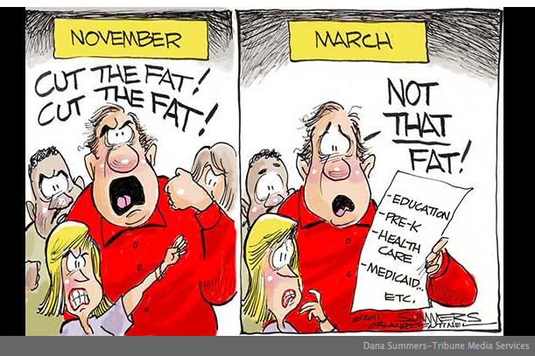
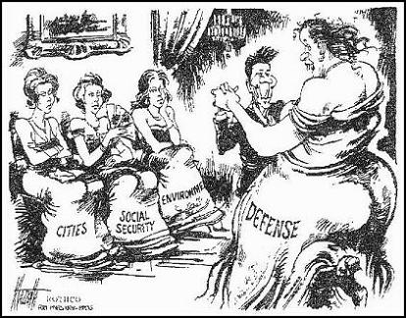

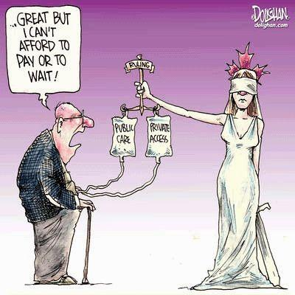

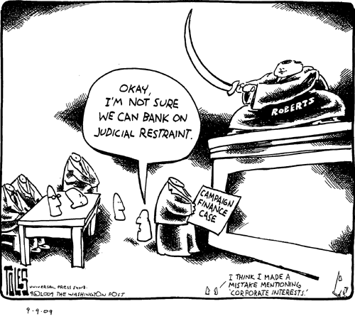

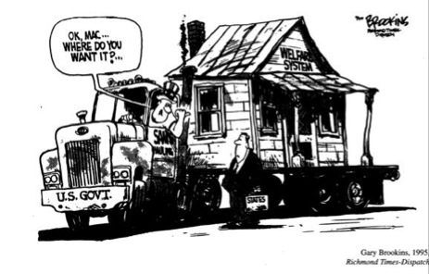
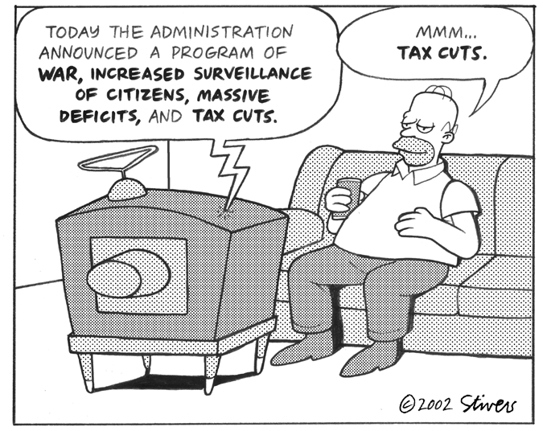

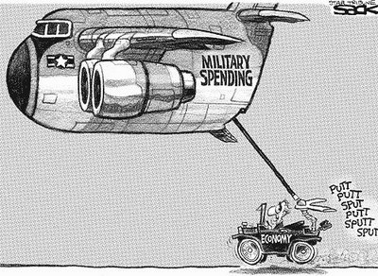

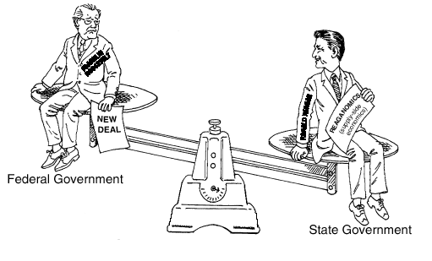
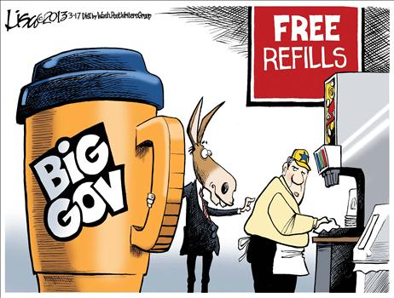

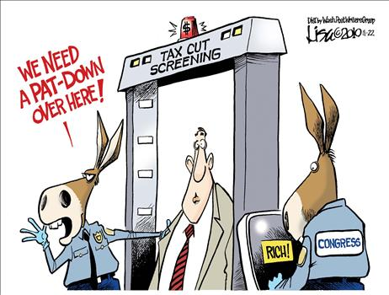
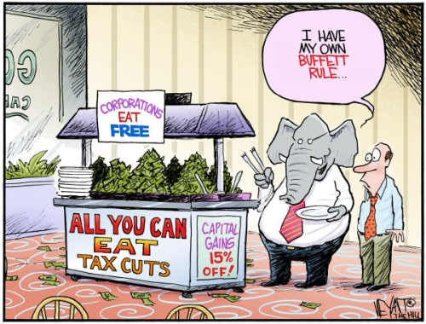

Part II. What does this cartoon below imply of state governments by Reagan as opposed to the Federal government?

Part III. Explain the following in your own words:

The “Reagan Revolution” extended beyond his tenure in office with:
- The election of his vice president, George H. W. Bush,
- The election of a centrist Democrat, William Clinton
- The Republican sweep of congressional elections and statehouses in the 1990s •
- The election of George W. Bush

____________________________________________________________________________
____________________________________________________________________________________________________________________________________________________________________________________________________________________________________

