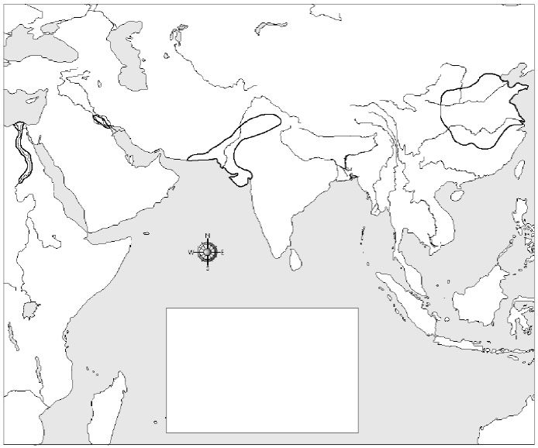
Part I: (Use the map above!) In the map key box, write the name of each river valley civilization and show what color will be used to represent it on the map. Then shade each river valley in.

Part II: Match the River Valley and the place name!
Egypt Indus River Valley
China Tigris & Euphrates River Valley
India Nile River Valley
Mesopotamia Huang He River Valley

Part III: Picking out details – read the paragraph below and highlight or underline the reasons why early civilizations settled near rivers.

All of the world’s earliest civilizations had something in common – they all arose in river valleys that were perfect locations for farming. Three key factors made river valleys good for farming. First, the fields that bordered the rivers were flat, which made it easier for farmers to plant crops. Second, the soils were nourished by flood deposits and silt, which made them very fertile. Finally, the river provided the water farmers needed for irrigation. (Source: World History. Holt McDougal)

