Objective:
You have been assigned topics in United States History that you must individually research and then construct a finished project on for each topic for two project grades. Each student will be provided 4x6 inch index cards to use for the finished project which can be hand drawn or completed with the help of a computer. Any work that cannot be completed in class must be completed in your own time. Assignment due dates will be posted in the classroom. You will work on this project in two parts with one project grade earned for the first half of the semester and a second project grade earned for the second half of the semester. The cards will be informative but still usable for a class game that we will model after other fun games such as Pokémon or Magic: The Gathering.
Task:
For this project, each student will individually create trading game cards on their assigned topics. You will create one 4x6 inch card per topic following the instructions given below.
Specific Directions/Trading Card Requirements:
For every topic that you are assigned, it will be designed as either “people”, “time period”, or a “power card”. All “people” cards will later be glued onto a specified size of green construction paper to designate it as a “people” card. All “power cards” will later be glued onto a specified size of red construction paper to designate it as a “power card”. All “time period” cards will later be glued onto a specified size of blue construction paper to designate it as a “time period” card.
This is how your card MUST be organized. Please make your card colorful, neat, and attractive. Only write on the non-lined side. Note: the amount of points each card is worth will be determined by the class as a group so do not list that on the card but leave that space blank!
Time Period History Points

(Picture of person/event/invention)
Name of person/event/invention under the picture

Key facts: (the more you list, the better your grade and the
higher the points for the card)
*
*
*
*
*
*
Grading Rubric
CATEGORY | 25 | 20 | 15 | 10 | 0
Followed Directions | All directions are followed in constructing the trading cards. | Most directions are followed in constructing the trading cards. The student’s final work could use a bit more editing before use in a whole class activity following the class objective. | Some of the directions are followed in constructing the trading cards but failure to follow directions does distract from the project’s goal. | Student did not make enough of an effort to follow directions. The final product does not meet the project objective. | Student did not turn in their project at all or within the required period for late assignments.
Assigned topics | Student completed all assigned topic trading cards. | Students turned in 95% of their assigned topic trading cards. | Students turned in 90% of their assigned topic trading cards. | Students did not complete 89% or less of their assigned topic trading cards which will hurt the class from meeting the project objective. | Student did not turn in their project at all or within the required period for late assignments.
Trading Card Content | Covers topic in-depth with details and examples. Subject knowledge is excellent. | Includes essential knowledge about the topic. Subject knowledge appears to be good. | Includes essential information about the topic but there are 1-2 factual errors. | Content is minimal OR there are several factual errors. | The cards are not usable for the class objective due to content or construction errors.
Attractiveness—Presentation and Project | Makes excellent use of font, color, graphics, effects, etc. to enhance the presentation. | Makes good use of font, color, graphics, effects, etc. to enhance to presentation. | Makes use of font, color, graphics, effects, etc. but occasionally these detract from the presentation content. | Use of font, color, graphics, effects etc. but these often distract from the presentation content. | The cards are not usable for the class objective.

Assigned Topics:
Black “Time Period” Cards:
European Exploration (VUS.2)
Colonization of the Americas (VUS.3)
Revolutionary Period (VUS.4)
Constitutional Period (VUS.5)
Early National Period (VUS.6)
Civil War and Reconstruction (VUS.7)
Late 19th to Early 20th Century—Domestic Affairs (VUS.8)
Late 19th to Early 20th Century—Foreign Affairs (VUS.9)
Roaring 20s through the Great Depression (VUS.10)
World War II (VUS.11-12)
Cold War (VUS.13)
Civil Rights Movement (VUS.14)
Recent Decades (VUS.15)
Blue “People” Cards (*means that the person could go in two time periods):

Abraham Lincoln
Adolf Hitler
Alexander Graham Bell
Alexander Hamilton*
Alger Hiss
Andrew Carnegie
Andrew Jackson
Andrew Johnson
Benito Mussolini
Benjamin Franklin
Booker T. Washington
Cavaliers
Christa McAuliffe
Christopher Columbus
Clarence Thomas
Conquistadors
Cornelius Vanderbilt
Dr. Jonas Salk
Dwight Eisenhower*
Eli Whitney
Elizabeth Cady Stanton
Eugene V. Debs
Fidel Castro
Franklin Roosevelt*
Frederick Douglass
George H.W. Bush
George Mason
George W. Bush
George Calvert
George Washington*
Harriet Beecher Stowe
Harriet Tubman
Harry Truman*
Henry Bessemer
Henry Clay
Henry Ford
Herbert Hoover
Hideki Tojo
Ida B. Wells
Ida Tarbell
J.P. Morgan
James Madison
James Monroe*
Jane Addams
Jefferson Davis
Jimmy Carter
John F. Kennedy
John Glenn
John Hay
John Jay
John Locke
John Marshall
John Rockefeller
John Rolfe
John Smith
Joseph McCarthy
Joseph Stalin
Lewis and Clark
Lyndon B. Johnson
Martin Luther King, Jr.
Mikhail Gorbachev
Nat Turner
Neil Armstrong
Nikita Khrushchev
Oliver Hill
Patrick Henry
Puritans
Richard Nixon
Robert E. Lee
Ronald Reagan
Rosenbergs
Rosie the Riveter
Ruth Bader Ginsburg
Sacajawea
Sally Ride
Samuel Gompers
Sandra Day O’Connor
Stephen Douglas
Susan B. Anthony
Theodore Roosevelt*
Thomas Edison
Thomas Jefferson*
Thomas Paine
Thurgood Marshall
Ulysses S. Grant
Upton Sinclair
W.E.B. DuBois
William Clinton
William Lloyd Garrison
William McKinley
William Taft
Winston Churchill
Woodrow Wilson*

Red “Power” Cards:

“Uncle Tom’s Cabin”
14 Point Plan
Agricultural Adjustment Act
Annexation of Hawaii
Antietam
Anti-Federalist Arguments against the Constitution
Articles of Confederation
Atom Bomb at Hiroshima and Nagasaki
Attack on Pearl Harbor
Battle of Britain
Bay of Pigs
Berlin Wall
Bessemer Steel Process
Bomb shelters
Brown v. Board of Education
Capitalism
Civil Rights Act of 1964
Columbian Exchange
“Common Sense”
Communism
Compromise of 1850
Compromise of 1877
Constitution
Cotton Gin
Cuban Missile Crisis
Declaration of Independence
Democratic Republicans Party Ideas
Dollar Diplomacy
Dred Scott Supreme Court Case
El Alamein
Emancipation Proclamation
Enlightenment
European diseases
Federal Deposit Insurance Corporation
Federalist Arguments for the Constitution
Federalist Political Party Ideas
Finance Industry
Fort Sumter
Geneva Convention
Gettysburg
Gettysburg Address
Gibbons v. Ogden
Great Awakening
Hawley Smoot-Act
Homestead Act
House of Burgesses
Hubble Telescope
Initiative
Invasion of Normandy
Iwo Jima and Okinawa
Kansas-Nebraska Act
Korean War
Laissez-faire economics
Lexington and Concord
Louisiana Purchase
Manhattan Project
Manifest Destiny
Marbury V. Madison
Marshall Plan
Massive Retaliation
Mayflower Compact
McCarthyism
McCulloch v. Maryland
Mechanical Reaper
Middle Passage
Midway
Missouri Compromise
Monroe Doctrine
NASA
New Deal
New Freedom Plan
North Atlantic Treaty Organization (NATO)
Oil
Open Door Policy
Panama Canal
Plessy v. Ferguson
Polio Vaccine
Proclamation of 1763
Progressive Movement
Recall
Referendum
Saratoga
Seneca Falls Declaration
Social Security
Spanish-American War
Square Deal
Stalingrad
Steel
Surrender at Appomattox Courthouse
Texas Revolution
The Liberator (Newspaper)
Town meetings/direct democracy
Trail of Tears
Transcontinental Railroad
Triangular Trade
Truman Doctrine
Vietnam War
Virginia Declaration of Rights
Virginia Statute for Religious Freedom
Voting Rights Act of 1965
War of 1812
War with Mexico
Warsaw Pact
Watergate
Women’s Suffrage Movement
Works Progress Administration
World War I
World War II
Treaty of Versailles
Yorktown

Model Card at the exact
dimensions with proper font and spacing.
Civil War and
Reconstruction (VUS.7) HP:____

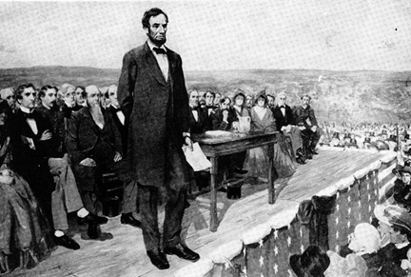
Abraham Lincoln
AKA “Honest Abe” Born 1809 Died 1865

Key facts:
- Republican President from 1861-1865
- Presided over the Union during the Civil War and was determined to put the country back together again
- Said in the Lincoln-Douglas debates that “A house divided against itself cannot stand.”
- Issued the Emancipation Proclamation which freed the slaves in the rebellious states
- *Gave the famous Gettysburg Address which referenced the Declaration of Independence on how the U.S. should be a country “of the people, by the people, and for the people”

Time Period Cards:
European Exploration VUS.2

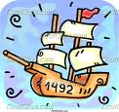
European Exploration
When the East meets the West

Key facts:
- The Old World Confronts the New World
- Often led to violent conflicts over the ownership of land
- European diseases wiped out millions of indigenous peoples
- American Indians were moved from their ancestral lands to accommodate the new European arrivals
- Exploration and colonization began a worldwide commercial expansion as products were exchanged between the Americas and Europe.
- This was when many thought going west was best.

Colonization of the Americas VUS.3

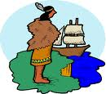
Colonization of the Americas
AKA Colonial America

Key facts:
- Economic and political institutions in the colonies developed in ways that were typically European or distinctively American
- Economic activity and political institutions of the three colonial regions reflect the resources and climate as well as the European origins of their settlers.
- There was a strong belief in private ownership of property and free enterprise in all colonies.

Revolutionary Period VUS.4

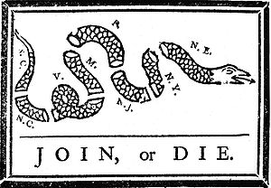
Revolutionary Period
The War for Independence Begins…….

Key facts:
- Enlightenment ideas inspired the colonists to declare independence from Britain over their political differences
- The Declaration of Independence become a road map for the new republic as it extended the franchise, provided for equality of opportunity, and guaranteed “unalienable rights”
- By the end of the war, there was little popular support for the war in Britain which contributed to America’s win.

Constitutional Period VUS.5

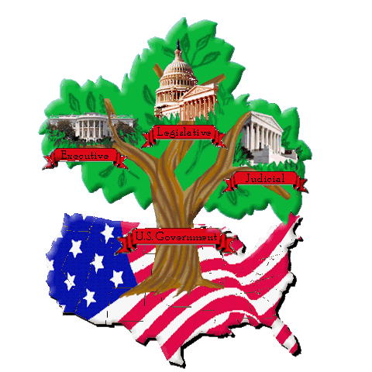
Constitutional Period
America’s 2nd attempt at a national government
Key facts:
- The Americans made two attempts to establish a workable government based on republican ideals: Articles of Confederation and the Constitution

- Fearful of a powerful central government like England’s, America’s political leaders created the Articles of Confederation. However, it will not be enough so the Constitution will replace it.

- Under the Constitution, the power is shared between the national government and the states. (= federalism)

- There is a system for orderly change to the Constitution through amendments.

Early National Period VUS.6

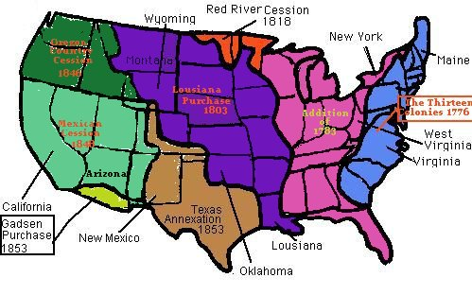
Early National Period
Baby America

Key facts:
- America will be tested on many fronts.

- Political parties, territorial acquisition, westward expansion and economic development, forced movement of Indians, a second war against the British, changing nature of politics, and growing sectional tensions were facets of early 19th century America.
- Different views on economic and foreign policy issues led to the development of the first American political parties in the1790s.

Civil War and VUS.7
Reconstruction

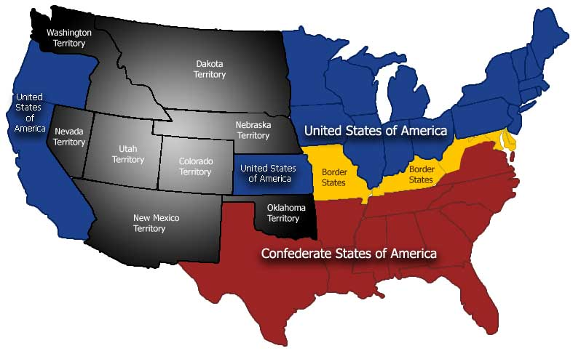
Civil War and Reconstruction
A nation divided…..

Key facts:
- Mounting sectional tensions and a failure of political will led to the Civil War.
- President Lincoln’s call for federal troops in 1861 for Ft. Sumter is considered to be the starting point of the Civil War by many.

- The secession of the southern states triggered a long and costly war that ended with Northern victory, a restoration of the Union, and the emancipation of the slaves.

Late 19th-Early 20th Century VUS.8
Domestic Affairs

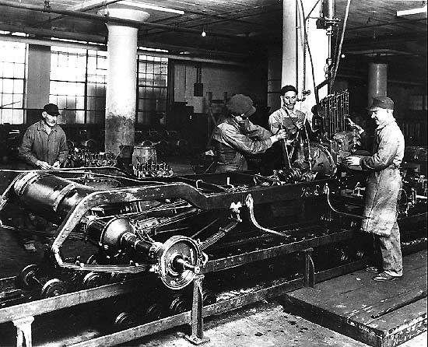
Late 19th-Early 20th Century—Domestic Affairs
America becomes “modern”
Key facts:
- Vast post-war changes: territorial expansion, westward movement, new immigration, growth of cities, and complete economic transformation lead to a much changed America.
- More immigrants are coming into America as more Americans are moving north and west

- A few Americans capitalize on inventions and innovations to become giants in their industrial fields but there is a backlash to this “income disparity” with the labor movement and Progressive Movement.

Late 19th-Early 20th Century VUS.9
Foreign Affairs

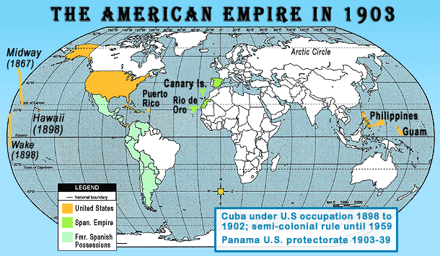
Late 19th-Early 20th Century—Foreign Affairs
America becomes a World Power
Key facts:
- Many 20th century American foreign policy issues have their origins in American foreign policy at the end of the 19th century.
- With industrialization, America abandoned its traditional isolationist role to expand its influence in the world and create international markets.
- The US abandoned its traditional isolationist foreign policy in this time period through its actions in Latin America and WWI.

Roaring 20s through the VUS.10
Great Depression
Roaring 20s through the Great Depression
From Boom to Bust
Key facts:
- A new popular culture was created during the prosperity of the 1920s that challenged traditional values.
- The 1929 Stock Market crash signaled the Great Depression with a major impact on the American people.
- The New Deal permanently altered the role of government in the economy. It changed people’s belief in the responsibility of the government to deliver public services, intervene in the economy, and to promote the general welfare.

World War II VUS.11-12

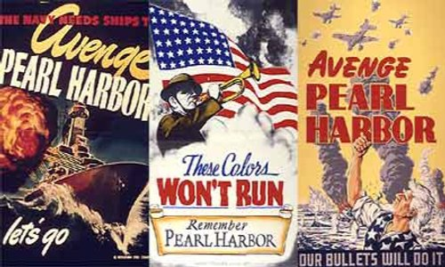
World War II
Our Greatest Generation

Key facts:
- The US gradually abandoned neutrality as events in Europe and Asia pulled the nations toward war.
- WWII began in Europe when Hitler invaded Poland in 1939, followed by the Soviet Union’s invasion of Poland and the Baltic countries from the eastern side.
- After the horrors of the Holocaust were revealed to the world, many promised that “never again” would the world allow such horrors to be committed against mankind.

Cold War VUS.13

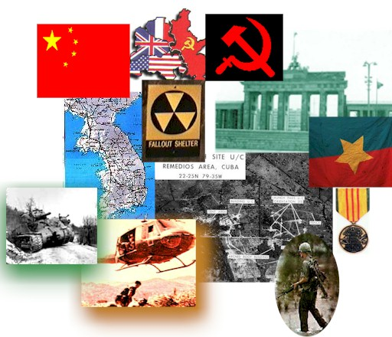
Cold War
The bi-polarization of Europe and the world
Key facts:
- Consequences of WWII produced the Cold War which set the framework for global politics for 45 years and influenced domestic politics and the role of government in the economy.

- The West represented the “best” while the East represented the “beast”

- The Truman Doctrine of “containment of communism” was a guiding principle throughout the Cold War. = Not to roll it back but to keep it from spreading and resist communist aggression into other countries.

Civil Rights Movement VUS.14

Civil Rights Movement
It was about time!
Key facts:
- African Americans, working through the court system with the NAACP and mass protest, reshaped public opinion and secured the passage of civil rights legislation.
- In the 1954 case of Brown v. Board of Education of Topeka, Kansas, the Supreme Court ruled that segregated schools are unequal and must desegregate.
- Martin Luther King, Jr. inspired participants in the 1963 March on Washington with his “I Have a Dream” speech.

Recent Decades VUS.15

Recent Decades
It’s a buffet of information!
Key facts:
- Economic, social, cultural and political developments in recent decades have resulted from Supreme Court decisions, immigration, scientific and technological developments, the role of government (including the Reagan Revolution), and the confrontation with terrorism.
- In the early 1960s, President Kennedy pledged support for the American space program.

- In the past three decades, technology and media have brought better access to communication and information for rural areas, businesses and individual consumers.

