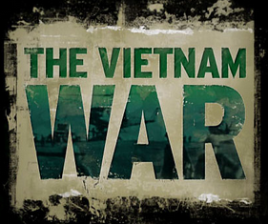

Station 8
The Vietnam War

Name ____________________________________________ Date ________________________ Core _________

Videos:

Ho Chi Minh Trail – 3:54

Causes of the Vietnam War – 8:51 mins

Vietnam War: History and Key Dates – 5:53 mins

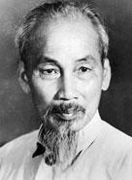
The Vietnam War was a long, costly armed conflict that pitted the communist regime of North Vietnam and its southern allies, known as the Viet Cong (supported by the Soviet Union and China), against South Vietnam and its principal ally, the United States, lasting for about 20 years.
The war began in 1954 (though conflict in the region stretched back to the mid-1940s), after the rise to power of Ho Chi Minh and his communist Viet Minh party in North Vietnam, and continued against the backdrop of an intense Cold War between two global superpowers: the United States and the Soviet Union. More than 3 million people (including 58,000 Americans) were killed in the Vietnam War; more than half were Vietnamese civilians. By 1969, at the peak of U.S. involvement in the war, more than 500,000 U.S. military personnel were involved in the Vietnam conflict. Growing opposition to the war in the United States led to bitter divisions among Americans, both before and after President Richard Nixon ordered the withdrawal of U.S. forces in 1973. In 1975, communist forces seized control of Saigon, ending the Vietnam War, and the country was unified as the Socialist Republic of Vietnam the following year and ruled by communism. The Vietnam War was a complete disaster for the United States.

ROOTS OF THE VIETNAM WAR
During World War II, Japan invaded and occupied Vietnam, a nation on the eastern edge of the Indochina Peninsula in Southeast Asia that had been under French administration since the late 19th century. Inspired by Chinese and Soviet communism, Ho Chi Minh formed the Viet Minh, or the League for the Independence of Vietnam, to fight both Japan and the French colonial administration. Japan withdrew its forces in 1945, leaving the French-educated Emperor Bao Dai in control of an independent Vietnam. Ho’s Viet Minh forces rose up immediately, seizing the northern city of Hanoi and declaring a Democratic Republic of Vietnam (DRV), also known as North Vietnam, with Ho as president.
Seeking to regain control of the region, France backed Bao and set up the state of Vietnam (South Vietnam) in July 1949, with Saigon as its capital. Armed conflict continued until a decisive battle at Dien Bien Phu in May 1954 ended in French defeat by Viet Minh forces. The subsequent treaty negotiations at Geneva split Vietnam along the latitude known as the 17th parallel (with Ho in control in the North and Bao in the South) and called for nationwide elections for reunification to be held in 1956. The country's name was also changed from Indochina to Vietnam. In 1955, however, the strongly anti-communist Ngo Dinh Diem pushed Bao aside to become president of the Government of the Republic of Vietnam (GVN), in South Vietnam.

VIETNAM WAR: U.S. INTERVENTION BEGINS
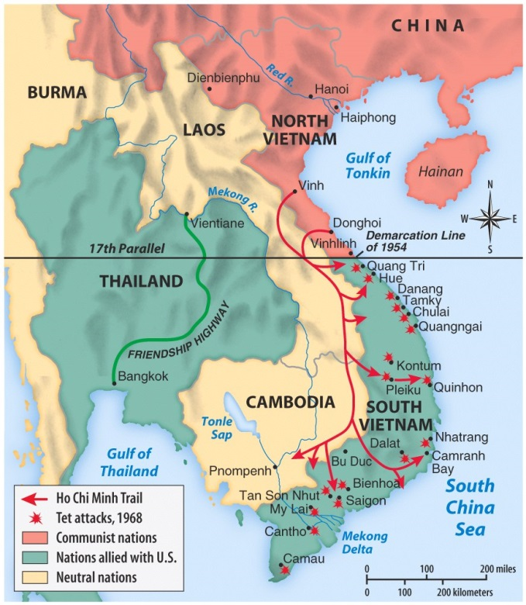
With the Cold War intensifying, the United States hardened its policies against any allies of the Soviet Union, and by 1955 President Dwight D. Eisenhower had pledged his firm support to Diem and South Vietnam. With training and equipment from American military and police, Diem’s security forces cracked down on North Vietnamese sympathizers in the south, whom he derisively called Viet Cong (or Vietnamese Communist), arresting some 100,000 people, many of whom were tortured and executed. By 1957, the Viet Cong and other opponents of Diem’s repressive regime began fighting back with attacks on government officials and other targets, and by 1959 they had begun engaging South Vietnamese Army forces in firefights.
By 1960, the National Liberation Front, or Viet Cong, which was the revolutionary political arm of North Vietnam, began to infiltrate into the south along the Ho Chi Minh Trail, which was a series of elaborate trails running from North Vietnam to South Vietnam through Laos and Cambodia created in 1959. The goal of the Viet Cong was to recruit support for the war and people who opposed Diem’s rule in South Vietnam. (It is important to understand that the Viet Cong fought in the southern reaches of South Vietnam while the North Vietnamese army battled closer to the 17th parallel, throughout the Vietnam War).
A team sent by President John F. Kennedy in 1961 to report on conditions in South Vietnam advised a build-up of American military, economic and technical aid in order to help confront the Viet Cong threat. Working under the “domino theory,” which held that if one Southeast Asian country fell to communism, many would follow, Kennedy increased U.S. aid, though he stopped short of committing to a large-scale military intervention.

VIETNAM WAR ESCALATES
A coup by some of his own generals succeeded in toppling and killing Diem and his brother, Ngo Dinh Nhu, in November 1963, three weeks before Kennedy was assassinated in Dallas, Texas. The ensuing political instability in South Vietnam persuaded Kennedy’s successor, Lyndon B. Johnson, and Secretary of Defense Robert McNamara to further increase U.S. military and economic support. The following August, after DRV torpedo boats attacked two U.S. destroyers (Maddox and Turner Joy, with no conclusive evidence) in the Gulf of Tonkin, Johnson ordered the retaliatory bombing of military targets in North Vietnam. Congress soon passed the Gulf of Tonkin Resolution, which gave Johnson broad war-making powers and to take any action deemed necessary to win. As a result, U.S. planes began regular bombing raids, codenamed Operation Rolling Thunder, the following February.
In March 1965, Johnson made the decision–with solid support from the American public–to send U.S. combat forces into battle in Vietnam. By June, 82,000 combat troops were stationed in Vietnam, and General William Westmoreland was calling for 175,000 more by the end of 1965 to shore up the struggling South Vietnamese army. Despite the concerns of some of his advisers about this escalation, and about the entire war effort as well as a growing anti-war movement in the U.S., Johnson authorized the immediate dispatch of 100,000 troops at the end of July 1965 and another 100,000 in 1966. In addition to the United States, South Korea, Thailand, Australia and New Zealand also committed troops to fight in South Vietnam (albeit on a much smaller scale).

STRATEGY OF ATTRITION IN VIETNAM
The U.S. used bombing raids to fight in North Vietnam, while U.S. military forces in South Vietnam pursued a policy of attrition, aiming to kill as many enemy troops as possible on the ground rather than trying to secure territory. Even as the body count (at times exaggerated by U.S. and South Vietnamese authorities) mounted steadily, DRV (North Vietnam’s army) and Viet Cong troops refused to stop fighting.
By November 1967, the number of American troops in Vietnam was approaching 500,000, and U.S. casualties had reached 15,058 killed and 109,527 wounded. As the war stretched on, some soldiers came to mistrust their government’s reasons for keeping them there, as well as Washington’s claims that the war was being won. Americans on the home front turned against the war as well by 1967.

IMPACT OF THE TET OFFENSIVE ON VIETNAM WAR
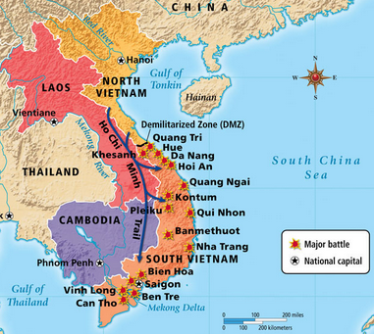
By the end of 1967, the United States had over 460,000 soldiers in combat. Operations against the North Vietnamese and Viet Cong were grueling, while the search-and-destroy strategy yielded only large numbers of enemy deaths that could be quantified as 'body count,' or a way to measure United States' progress in the war. At the onset of 1968, the United States, South Vietnam and North Vietnam agreed to a temporary ceasefire to observe Tet, the Vietnamese Lunar New Year. The temporary ceasefire, however, was a hoax implemented by North Vietnam.
By the end of 1967, North Vietnam’s communist leadership was growing impatient as well, and sought to strike a decisive blow aimed at forcing the better-supplied United States to give up hopes of success. On January 31, 1968, some 70,000 North Vietnamese forces launched the Tet offensive (named for the lunar new year), a coordinated series of fierce attacks on more than 100 cities and towns in South Vietnam. Though taken by surprise, U.S. and South Vietnamese forces managed to strike back quickly, and the communists were unable to hold any of the targets for more than a day or two. This was a definite turning point in the war, as Americans at home watched the horrors of the invasion unfold on television. With his approval ratings dropping in an election year, Johnson called a halt to bombing in much of North Vietnam in March (though bombings continued in the south) and promised to dedicate the rest of his term to seeking peace rather than reelection, as a response to the cry from Americans to end the war in Vietnam. Peace talks between the U.S. and North Vietnam opened in Paris that May 1968, but peace could not be reached and Richard Nixon was elected president in the U.S.

VIETNAM WAR ENDS: FROM VIETNAMIZATION TO WITHDRAWAL under President Richard Nixon
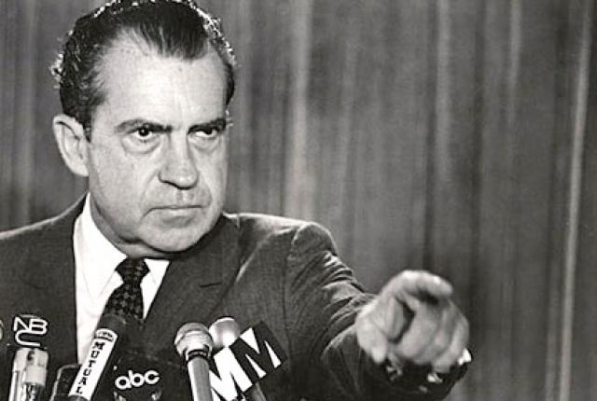
In an attempt to limit the volume of American casualties, Nixon announced a program of withdrawing troops, increasing aerial and artillery bombardment and giving South Vietnamese control over ground operations. In addition to this policy, which he called “Vietnamization,” or turning the war over to South Vietnam, Nixon continued public peace talks in Paris, conducted by Secretary of State Henry Kissinger beginning in the spring of 1968. The North Vietnamese continued to insist on complete U.S. withdrawal as a condition of peace, however, and the next few years would bring even more carnage, including the horrifying revelation that U.S. soldiers had massacred more than 400 unarmed civilians in the village of My Lai in March 1968.
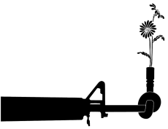
Anti-war protests continued to build as the conflict wore on. In 1968 and 1969, there were hundreds of anti-war marches and gatherings throughout the country. On November 15, 1969, the largest anti-war protest in American history took place in Washington, D.C., as over 250,000 Americans gathered peacefully, calling for withdrawal of American troops from Vietnam. Tens of thousands of soldiers received dishonorable discharges for desertion, and about 500,000 American men from 1965-73 became “draft dodgers,” with many fleeing to Canada to evade conscription. Nixon ended draft calls in 1972, and instituted an all-volunteer army the following year, but support for the Vietnam War was almost completely gone.
By the end of June 1972, however, after another failed offensive into South Vietnam, North Vietnam was finally willing to compromise. Kissinger and North Vietnamese representatives drafted a peace agreement by early fall, but leaders in South Vietnam rejected it, and in December Nixon authorized a number of bombing raids against targets in North Vietnam. Known as the Christmas Bombings, the raids drew international condemnation (ridicule or rejection).

LEGACY OF THE VIETNAM WAR
In January 1973, the United States and North Korea concluded a final peace agreement, ending open hostilities between the two nations. War between North and South Vietnam continued, however, until April 30, 1975, when DRV forces captured Saigon in South Vietnam, renaming it Ho Chi Minh City (Ho himself died in 1969). The Fall of Saigon brought an end to the conflict in Vietnam.
The long conflict had affected an immense majority of the country’s population; in eight years of warfare, an estimated 2 million Vietnamese died, while 3 million were wounded and another 12 million became refugees. War had decimated the country’s infrastructure and economy, and reconstruction proceeded slowly. In 1976, Vietnam was unified as the Socialist Republic of Vietnam.
In the United States, the effects of the Vietnam War would linger long after the last troops returned home in 1973. The nation spent more than $120 billion on the conflict in Vietnam from 1965-73; this massive spending led to widespread inflation, exacerbated by a worldwide oil crisis in 1973 and skyrocketing fuel prices. Psychologically, the effects ran even deeper. The war had pierced the myth of American invincibility, and had bitterly divided the nation. Many returning veterans faced negative reactions from both opponents of the war (who viewed them as having killed innocent civilians) and its supporters (who saw them as having lost the war), along with physical damage including the effects of exposure to the harmful chemical herbicide Agent Orange, millions of gallons of which had been dumped by U.S. planes on the dense forests of Vietnam. In 1982, the Vietnam Veterans Memorial was unveiled in Washington, D.C. On it were inscribed the names of 57,939 American armed forces killed or missing during the war; later additions brought that total to 58,200.

Sources:
http://education-portal.com/academy/lesson/the-vietnam-war-causes-conflicts-effects.html
http://www.history.com/topics/vietnam-war

Additional Videos:

Huey Helicopters – 1:30 mins

Cu Chi Tunnels – 1:40 mins

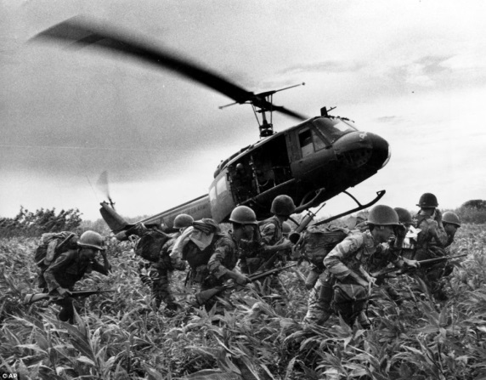
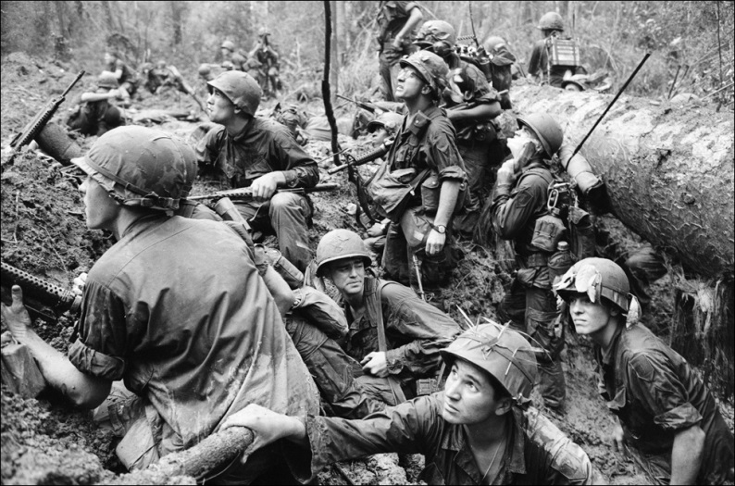

Station 8
The Vietnam War

Name ____________________________________________ Date ________________________ Core _________

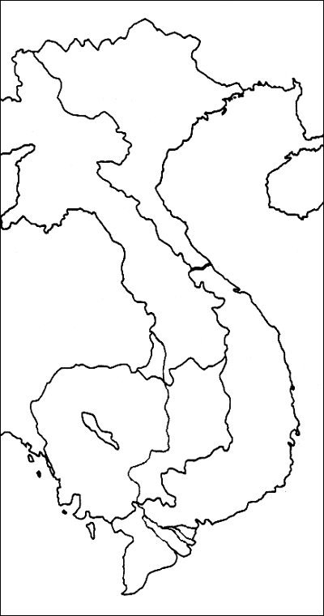
1. Define the following terms:
- Ho Chi Minh

- Viet Cong

- Hanoi

- Saigon

- Ho Chi Minh Trail

- Dwight D. Eisenhower

- John F. Kennedy

- Lyndon B. Johnson

- Gulf of Tonkin Resolution

- Richard Nixon

- Tet Offensive

- Vietnamization

- Socialist Republic of Vietnam

2. Using the map provided, Locate and Label Vietnam. Color the following:
Red – Communist Blue – Not Communist

3. Summarize the “Roots of the Vietname War” section of your reading.

4. Which countries end up supporting North Vietnam?

5. Which countries end up supporting South Vietnam?

6. What was the role of the Viet Cong during the Vietnam War?

7. What did President Kennedy decide the U.S. should do during the Vietnam War?

8. Summarize the “VIETNAM WAR ESCALATES” section of your reading.

9. Describe the Tet Offensive. What was it? What was the outcome?

10. How does the Vietnam War change under President Nixon?

11. Who does the Vietnam War end?

12. Why would the Vietnam War be considered a failure for the U.S.?

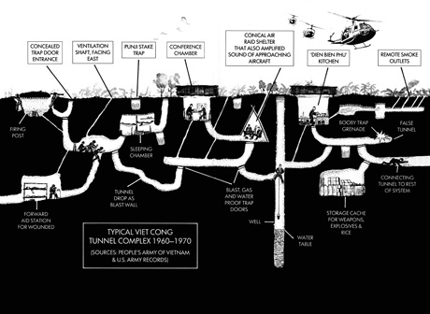

13. Using the image provided, answer the following question: Why do you think it was difficult to defeat the Viet Cong in South Vietnam? (EXPLAIN YOUR ANSWER)

