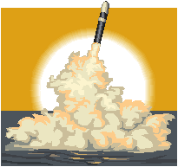

Station 7
Bay of Pigs Invasion and the Cuban Missile Crisis

Name ____________________________________________ Date ________________________ Core _________

Videos:

Cuban Missile Crisis – Summary – 5:29 mins
Jeffery Lewis – Cuban Missile Crisis – 2:33 mins

Cuban Missile Crisis – Three Men Go to War – intro – 2:50 mins

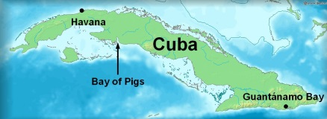
Today, it's hard to remember that the U.S. and the Soviet Union had thousands of nuclear warheads pointed at each other, ready to fly at a moment's notice. But for a long time, there was a possibility that between the two nations, all life on Earth could be extinguished. And that possibility was never more real, or closer, than it was in October 1962, during the Cuban missile crisis.

The Bay of Pigs
In 1959, the island of Cuba underwent a revolution. The much-hated dictator, Fulgencio Batista, was overthrown and was replaced by Fidel Castro. The U.S. was strongly suspicious of Castro; Batista had been a strong American ally, and the U.S. was pretty certain that Castro was communist. This suspicion was confirmed on Dec. 19, 1960, when Castro openly aligned with the Soviet Union, which meant that now, a communist ally of our chief rival was directly on the U.S.'s doorstep.
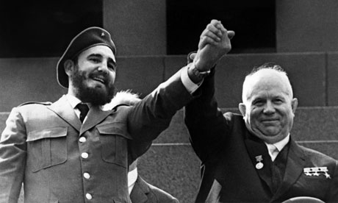
What does the U.S. do about this? Well, the president at the time, John F. Kennedy, promised in April 1961 not to intervene militarily to overthrow Castro. However, he did not keep his promise. Later that same month, around 1400 Cuban exiles (anti-Communists who had fled the country when Castro took over) landed on the coast of Cuba at a place called The Bay of Pigs. They had been trained and equipped by the U.S. Central Intelligence Agency. Their goal was to lead the popular uprising against Castro they were sure would follow their arrival. What happened instead was a complete failure and the Soviet Union offering more support to Fidel Castro and Cuba.
Cuba’s alliance with the Soviet Union was a huge strategic and military advantage to the Soviet Union. The United States had military bases and missile sites throughout Europe, most notably in Turkey. If you know your geography, Turkey borders the Soviet Union. This posed a direct threat to the Soviet Union. It gave the United States a tremendous strategic advantage. Many Soviet officials doubted the accuracy and reliability of Soviet long-range intercontinental ballistic missiles (ICBMs). It was thus in the Soviet Union's best interest to establish medium-range and intermediate-range missile sites in the Western Hemisphere, like Cuba.

Cuban Missile Crisis
On October 14, 1962, American U-2 spy planes took photographs of what appeared to be mobile missile launchers in remote areas of Cuba, which is only 90 miles or so from Key West, Florida. It was clear, upon analysis, that the missiles on the launchers were Soviet-made medium range ballistic missiles (MRBMs), which could be launched without warning and strike targets in the United States, as far away as the Pacific Northwest, before America could respond. The U.S. responded to this perceived threat, and the ensuing 13-day standoff became what is known as the Cuban missile crisis.
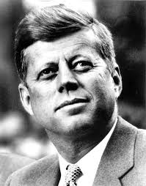
Kennedy was faced with a difficult choice: if he did nothing, then the Soviets, under Nikita Khrushchev, would be convinced that he had backed down, and they could try to test U.S. power in other countries. If he did what many in the U.S. military wanted, which was to invade Cuba outright, it would certainly mean war; and the Soviets had promised a full retaliatory response, which would involve nuclear weapons. To deal with the crisis, Kennedy convened the Executive Committee of the National Security Council, or EXXCOMM, which was a group of advisors who offered insight into the crisis in Cuba. Members of EXXCOMM proposed a variety of tactics to deal with the missile threat, including an air strike, land invasion, and a naval blockade. Some also suggested the United States should do nothing at all. Most advisors suggested a full-scale invasion of Cuba, but Kennedy was inclined to show more restraint. Here is timeline of the events:
- October 14, 1962: American spy planes take photographs of what appear to be mobile Soviet-made missile launchers in remote areas of Cuba.
- October 17, when U-2 flights found evidence of intermediate range ballistic missiles (IRBMs), which could reach anywhere in the continental United States. The threat was now very real.
- October 20: President Kennedy and his advisors call for a quarantine of Cuba, in which the U.S. Navy would block the coast and prevent any ship from reaching port. This would stop any new missiles from reaching Cuba, but it wouldn't remove the ones already there. This was technically not an act of war (the word 'quarantine' was used since 'blockade' would be an act of war), so Kennedy could claim that he wasn't escalating the conflict.
- October 22: Kennedy announces the quarantine of Cuba on television. U.S. military forces are moved to DEFCON 3 (DEFCON refers to the 'global defense condition'; DEFCON 5 is peace, DEFCON 1 is active war).
- October 23: U.S. Navy ships take up position on the 'quarantine line,' 800 miles from Cuba. Kennedy receives a letter from Khrushchev calling the situation 'a serious threat to peace and security.'
- October 24: Soviet ships en route to Cuba begin to slow down or change course. U.S. military forces go to DEFCON 2.
- October 25: Kennedy sends a letter to Khrushchev in which he claims the USSR is responsible for the current crisis. The President's advisors come up with a possible way out of the standoff: the U.S. would remove nuclear missiles from Turkey, an ally nation, which were 'due for replacement,' in exchange for Soviet removal of the missiles in Cuba.
- October 26: The CIA reports that the Soviets seem to be accelerating their construction of missile sites in Cuba and are now trying to camouflage the missile launchers. At the same time, a letter arrives from Khrushchev in which the Soviets pledge to dismantle the missiles in exchange for an American pledge never to invade Cuba.
- October 27: A second letter from Khrushchev arrives, now insisting on a trade for missiles: the U.S. missiles in Turkey for the Soviet missiles in Cuba.
- October 27: Robert Kennedy, the Attorney-General and the President's brother, meets with Anatoly Dobrynin, the Soviet ambassador to the U.S. He tells Dobrynin that the U.S. government will pledge not to invade Cuba, and that the missiles in Turkey will be removed within six months. Also, if any information about this pledge leaked prior to the six-month deadline, the Kennedy administration would deny the deal.
- October 28: Khrushchev announces, over Radio Moscow, that he has agreed to remove the missiles from Cuba.

The Aftermath
The Cuban missile crisis was a diplomatic triumph for the Kennedy administration and an embarrassment for the Soviet leadership. The only major concession by both sides, after the crisis, was the creation of creation the Moscow-Washington Hotline, a direct link of communication between the two superpowers, to ensure direct communication between the two nations' leaders in the future.

Sources:
http://education-portal.com/academy/lesson/the-cuban-
missile-crisis-definition-facts-timeline.html
http://education-portal.com/academy/lesson/communism-and-
the-cuban-revolution-castro-the-bay-of-pigs-the-cuban-missile-crisis.html

Additional Video:
Cuban Missile Crisis – Scariest Speech Ever – 3:14

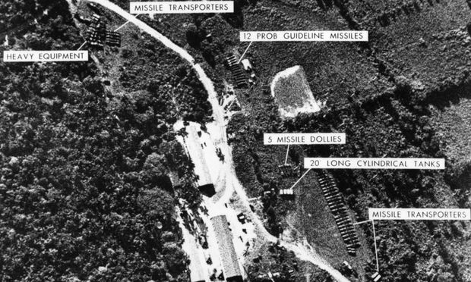

Examples of the images President Kennedy received from the U-2 Spy plane

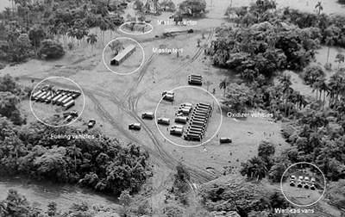
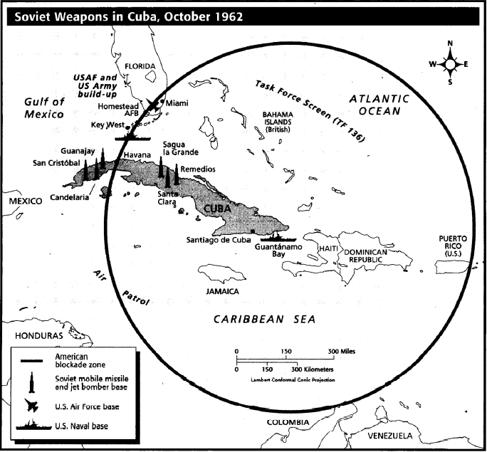
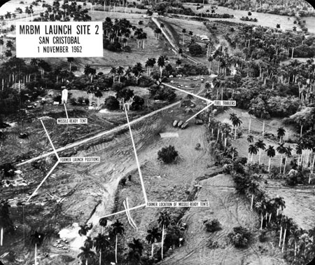
Map of the Cuban Missile Crisis

Station 7 - Questions
Bay of Pigs Invasion and the Cuban Missile Crisis

Name ____________________________________________ Date ________________________ Core _________

1. Define the following terms:
- Cuban Missile Crisis -

- Fidel Castro –

- The Bay of Pigs -

- John F. Kennedy –

- Nikita Khrushchev –

- Executive Committee of the National Security Council (EXXCOMM) –

- Quarantine -

2. Describe the Bay of Pigs Invasion. What was it? What was the outcome?

3. Why would the Soviet Union want to be allies with Cuba?

4. What does the U.S. have in Turkey that is a concern of the Soviet Union?

5. Describe the Cuban Missile Crisis. What was it? What was the outcome?

6. What kind of impact do you think the “Moscow-Washington Hotline” had on the rest of the Cold War?

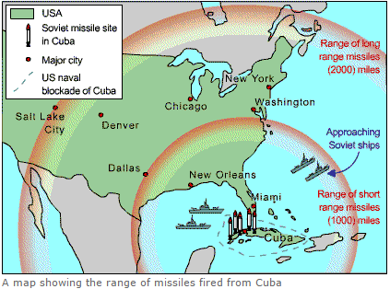
7. Using the image provided, answer the following question: If Cuba was allowed to keep the Soviet missiles, could where you live be affected by a nuclear attack? (EXPLAIN YOUR ANSWER)

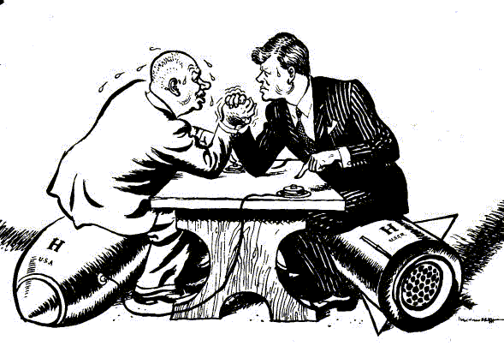
8. Using the image provided, answer the following question: How does this political cartoon symbolize or represent the Cuban Missile Crisis? (EXPLAIN YOUR ANSWER)

9. President Kennedy was offered several options to deal with the Cuban Missile Crisis. These options were as follows:
- Air Strike – bombing the missile sites in Cuba
- Land Invasion of Cuba – to take control of Cuba and the missile sites
- Naval Blockade – to stop the Soviets from transporting more missiles and missile equipment to Cuba
- Do Nothing

Using the examples of the images President Kennedy was shown from the U-2 Spy Plane, Map of the Cuban Missile Crisis, and the reading, answer the following question: What would you do if you were President Kennedy? (EXPLAIN YOUR ANSWER)

