Station 5
Nuclear Arms Race and the Space Race

Name ____________________________________________ Date ________________________ Core _________

Videos:

The Cold War and Nuclear Arms Race – 5:32 mins

Space Race – 20th century timeline and firsts – 5:50 mins

Kennedy’s Moon Speech – 2:02 mins

Nuclear Arms Race
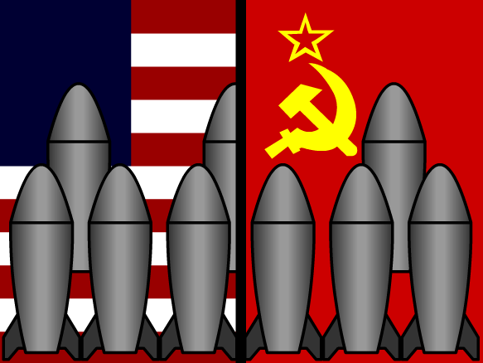
The nuclear arms race was a competition between the United States and the Soviet Union for nuclear weapons superiority lasting throughout the Cold War. The nuclear arms race really began to take off immediately after the United States successfully exploded two atomic bombs over Japan in 1945.
Jealous of the United States' new technology, and not wanting to be outdone, the Soviet Union was determined to develop their own atomic bomb as soon as possible. The United States and its Western European allies tried to prevent the Soviets from gaining atomic technology. However, through espionage (spying) and independent research, the Soviet Union developed their own atomic bomb project in the years following World War II. In August 1949, the Soviets successfully conducted their first atomic weapons test, codenamed First Lightning.

The 1950s and 1960s
- Codenamed Ivy Mike, the United States exploded the world's first hydrogen bomb in November 1952.
- The Soviets followed with their own hydrogen bomb in 1955.
- The world's first ICBM was the Soviet R-7. The United States followed shortly after with their Atlas Missile.
  - The development of intercontinental ballistic missiles, or ICBMs in the late 1950s changed Cold War military strategy. An ICBM is a long-range ballistic missile, capable of being launched from one continent to another.
- Mutually Assured Destruction (MAD) was a theory developed during the Cold War because both superpowers were capable of pushing a button and virtually obliterating one another within a matter of minutes. In other words, if one country launched their nuclear weapons, the other country could easily launch their own nuclear weapons and both countries would be destroyed.
  - Some viewed this doctrine as a deterrent (to prevent) to war because both countries would be less likely to launch missiles knowing that it would only result in mutual destruction.
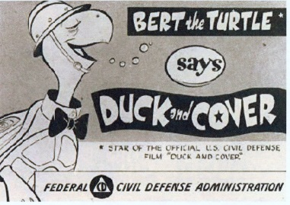
- One of the most critical moments of the nuclear arms race was the Cuban Missile Crisis in October 1962. Throughout the Cuban Missile Crisis many Americans feared they were standing on the brink of World War III.

The nuclear arms race resulted in widespread anxiety for both the American and Soviet peoples. In the United States, some families built homemade underground bomb shelters. In many schools, students practiced 'Duck and Cover' drills, in which they would crawl under their desk and cover their heads with their hands.

The 1970s
- Fear over nuclear weapons proliferation (rapid increase in numbers) prompted the United States and the Soviet Union to negotiate arms reductions, called the Strategic Arms Limitation Talks, or SALT.
- The U.S. and Soviet Union began to focus their attention on anti-ballistic defense technology, designed to stop ICBMs before they hit their target
  - U.S. President Ronal Reagan called for a defense system known as Strategic Defense Initiative, or SDI. Critics said it could not be done and mocked the idea by referring to it as “Star Wars”

The Cold War, and with it the nuclear arms race, came to a rather abrupt end when the Soviet Union dissolved in 1991. While today there is some degree of tension between the United States and Russia, it is nothing like it had been throughout the Cold War. Today, nuclear weapons proliferation and nuclear terrorism pose a far bigger threat than any kind of arms race.

THE SPACE RACE
The space race was a competition between the U.S. and the Soviet Union to prove the superiority of their technology.
Beginning in the late 1950s, both countries wanted to be able to fire weapons across the ocean, put satellites into space to spy on each other, and to show scientific excellence by putting a man on the moon.

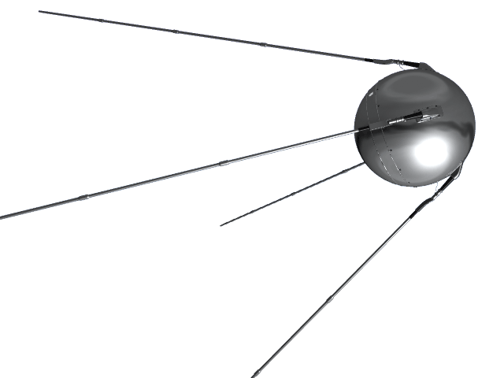
Space Race TimeLine
- On October 4, 1957, a Soviet R-7 intercontinental ballistic missile launched Sputnik (Russian for “traveler”), the world’s first artificial satellite and the first man-made object to be placed into the Earth’s orbit.
  - Sputnik’s launch came as a surprise, to most Americans, showing the world the U.S. was lacking in space technology and increasing the fear the nuclear weapons could be launched across oceans.
- In 1958, the U.S. launched its own satellite, Explorer I, designed by the U.S. Army
- That same year, President Dwight Eisenhower signed a public order creating the National Aeronautics and Space Administration (NASA), a federal agency dedicated to space exploration.
- In 1959, the Soviet space program took another step forward with the launch of Luna 2, the first space probe to hit the moon.
- In April 1961, the Soviet cosmonaut Yuri Gagarin became the first person to orbit Earth, traveling in the capsule-like spacecraft Vostok 1.
- On May 1961, astronaut Alan Shepard became the first American in space (though not in orbit), as part of Project Mercury
- Later that May, President John F. Kennedy made the bold, public claim that the U.S. would land a man on the moon before the end of the decade.
- In February 1962, John Glenn became the first American to orbit Earth, and by the end of that year, the foundations of NASA’s lunar landing program–dubbed Project Apollo–were in place.
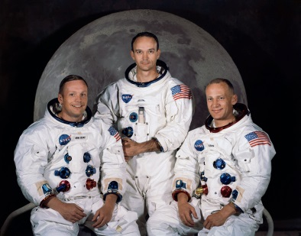
- December 1968 saw the launch of Apollo 8, the first manned space mission to orbit the moon, from NASA’s massive launch facility on Merritt Island, near Cape Canaveral, Florida.
- On July 16, 1969, U.S. astronauts Neil Armstrong, Edwin “Buzz” Aldrin and Michael Collins set off on the Apollo 11 space mission, the first lunar landing attempt.
- After landing successfully on July 20, Armstrong became the first man to walk on the moon’s surface; he famously called the moment “one small step for man, one giant leap for mankind.”

CONCLUSION OF THE SPACE RACE
By landing on the moon, the United States effectively “won” the space race that had begun with Sputnik’s launch in 1957. With the conclusion of the space race, U.S. government interest in lunar missions waned after the early 1970s. In 1975, the joint Apollo-Soyuz mission sent three U.S. astronauts into space aboard an Apollo spacecraft that docked in orbit with a Soviet-made Soyuz vehicle. When the commanders of the two crafts officially greeted each other, their “handshake in space” served to symbolize the gradual improvement of U.S.-Soviet relations in the late Cold War-era.
Sources:
http://www.history.com/topics/space-race
http://education-portal.com/academy/lesson/nuclear-arms-race.html

Additional Videos:
10 horrifying facts about nuclear war – 3:12 mins

Station 5 - Questions
Nuclear Arms Race and the Space Race

Name ____________________________________________ Date ________________________ Core _________

1. Define the following terms:
- Nuclear Arms Race –

- Space Race –

- Intercontinental Ballistic Missiles (ICBM) –

- Strategic Arms Limitation Talks (SALT) –

- Sputnik –

- Apollo 11 –

- National Aeronautics and Space Administration (NASA) –

- Mutually Assured Destruction (MAD) -

2. Create a timeline of at least 5 important Nuclear Arms Race events and at least 5 Space Race events. (Everything can be on one timeline, make sure you include the EVENT and DATE.)

__________________________________________________________________________________________________

__________________________________________________________________________________________________

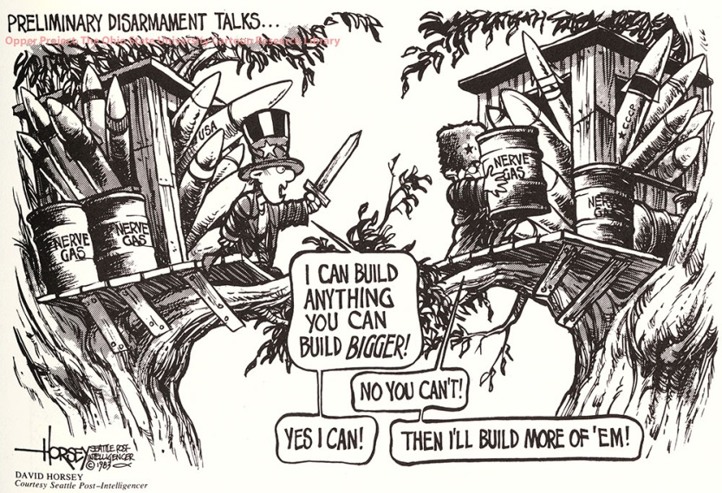
3. Using the image provided, answer the following question: How does this image explain the Nuclear Arms Race and the Space Race between the U.S. and the Soviet Union? EXPLAIN YOUR ANSWER.

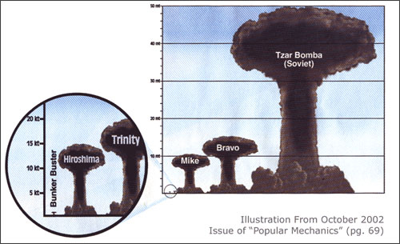
4. Using the image provided, answer the following question: What effect did the Nuclear Arms Race have on the nuclear technology? EXPLAIN YOUR ANSWER.

5. Based on ALL of the information provided (reading, videos, and images), answer the follow questions:
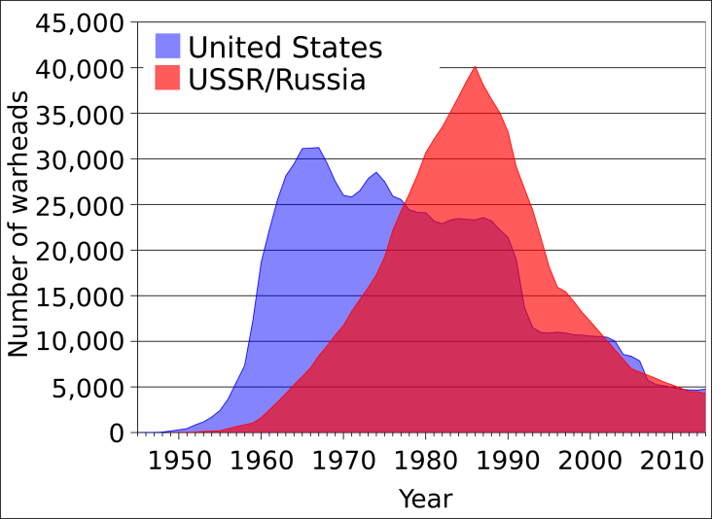
- Who won the Space Race? (EXPLAIN)

- Who won the Nuclear Arms Race? (Explain)

