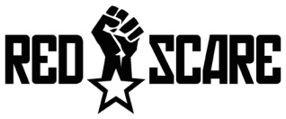
Station 4
Red Scare and McCarthyism

Name ____________________________________________ Date ________________________ Core _________

Videos:

McCarthyism – Better to be dead than red – 6:03 mins

How to spot a Communist – 1:03 mins

With the onset of the Cold War, Americans were made to believe that communists were figuratively lurking around the corner. This fear of the 'red menace,' or communism, caused changes in government policy, both internationally and domestically, due to the fear the Soviet spies might be actively working inside America and posing a threat to U.S. security. Such ideas were not totally unfounded. The Union of Soviet Socialist Republics (USSR) had long carried out espionage (spying) activities inside America with the aid of U.S. citizens, particularly during World War II. As apprehension about Soviet influence grew as the Cold War heated up, U.S. leaders decided to take action.

Defining McCarthyism and the Red Scare
The Red Scare, which gained popularity during the First World War, represented the widespread concern that Americans had developed over the fear of communist (or anarchist, during the First World War era) subversion within society. (Communists were often referred to as “Reds” for their allegiance to the red Soviet flag.) Americans believed, especially during the Cold War, that communism was attempting to infiltrate every aspect of their lives. While this is not necessarily the best analogy, you can relate the widespread fear of communism during the Cold War as being similar to the heightened alert Americans had toward terrorism and suspected terrorists during the beginning of the modern century.
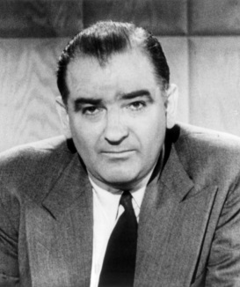
Instigating this fear was Joseph McCarthy. McCarthy was a Republican senator from Wisconsin and was the leader behind the ethos of McCarthyism, which was the practice of attempting to minimize the threat of communism by accusing and detaining suspects deemed to be a security threat or disloyal to the United States. Investigations ranged from the federal government (especially the State Department), to Hollywood, to the general American public. No one was safe because McCarthy was the judge, jury and executioner. McCarthy's harsh campaign of identifying and eliminating suspected communists raged from roughly 1950 to 1954. This was a rude awakening to Americans who thought the trials and tribulations of the Cold War rested outside of the United States borders.

Important Events and People During the Cold War Red Scare
- 1938 – U.S. House of Representatives – House of Un-American Activities Committee (HUAC) – was a government organization in charge of investigating and exposing communist working inside of the federal government or subversive elements working in the Hollywood film industry
- 1947 - Harry S. Truman – Executive Order 9835 (Loyalty Order) – mandated that all federal employees be analyzed to determine whether they were sufficiently loyal to the U.S. government.
- 1950 – U.S. Congress – McCarran Internal Security Act – required that all “subversives” in the U.S. submit to government supervision and Communist organizations to register with the U.S. government.
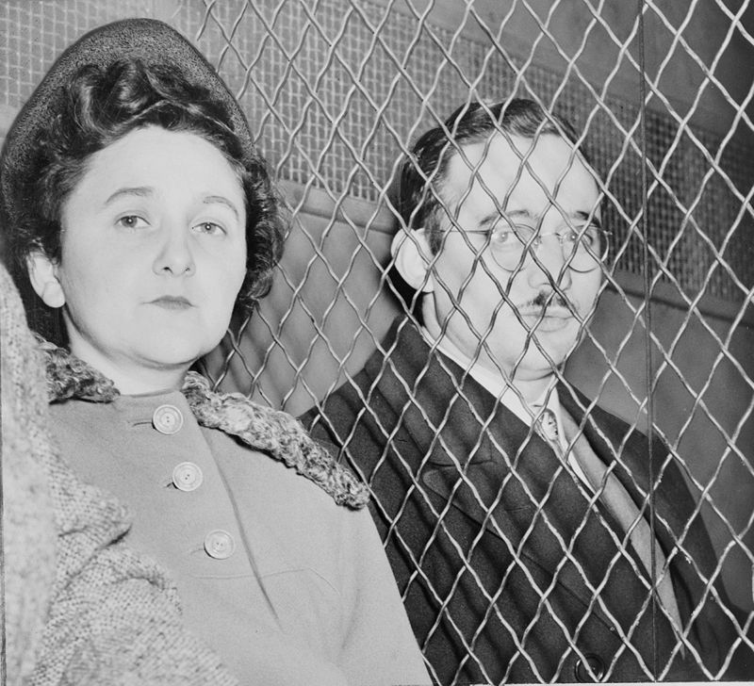
- J. Edgar Hoover – Head of the FBI– help aid many of the legislative investigations of communist activities. One of the most famous was the case against Julius and Ethel Rosenberg, who were convicted of espionage in 1951 and executed two years later, for passing secrets about the atomic bomb to the Soviet Union.
- Joseph R. McCarthy – Senator – became the person most closely associated with the anticommunist crusade to remove and punish communist supports in the U.S.

The Rise of McCarthyism
Beginning in 1950, McCarthy targeted individuals within the United States who were suspected communists. His witch-hunt began at the federal level. McCarthy used hearsay and intimidation to establish himself as a powerful and feared figure in American politics, often accusing suspects with very little evidence. He leveled charges of disloyalty at celebrities, intellectuals and anyone who disagreed with his political views, costing many of his victims their reputations and jobs. Despite a lack of any proof of subversion, more than 2,000 government employees lost their jobs as a result of McCarthy’s investigations. He accused individuals, such as General George Marshall, the U.S. Army, President Truman, Charlie Chaplin, Langston Hughes, Pete Seeger, J. Robert Oppenheimer and Albert Einstein. McCarthy contended that all of these individuals worked within communist organizations and/or belonged to the Communist Party of America. McCarthy’s witch hunt continued until his colleagues formally denounced his tactics in 1954.

The Downfall of McCarthyism
McCarthy's aggressive campaign of routing out suspected communists eventually ran out of fuel. Two major hearings brought about the downfall of McCarthyism: the Army-McCarthy Hearings and McCarthy's censure, both in 1954. By the time the hearings were over, McCarthy had lost most of his allies. The Senate voted to condemn him for his “inexcusable,” “reprehensible,” “vulgar and insulting” conduct “unbecoming a senator.” He kept his job but lost his power, and died in 1957 at the age of 48. The climate of fear and repression linked to the Red Scare finally began to ease by the late 1950s.

Effects on the Everday American
As the Red Scare intensified, its political climate turned increasingly conservative. Elected officials from both major parties sought to portray themselves as staunch anticommunists, and few people dared to criticize the questionable tactics used to persecute suspected radicals and communist supporters. Support for free speech and other civil liberties eroded (reduced) significantly, as people hoped to keep the U.S. free of Communism.
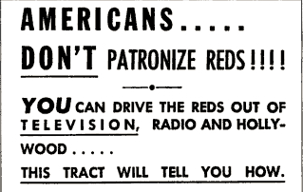
Americans also felt the effects of the Red Scare on a personal level, and thousands of alleged communist sympathizers saw their lives disrupted. They were hounded by law enforcement, alienated from friends and family and fired from their jobs. While a small number of the accused may have been aspiring revolutionaries, most others were the victims of false allegations or had done nothing more than exercise their democratic right to join a political party. Though the climate of fear and repression began to ease in the late 1950s, the Red Scare has continued to influence political debate in the decades since and is often cited as an example of how unfounded fears can compromise civil liberties.
Lesson Summary
Beginning in 1950, Senator Joseph McCarthy launched a campaign, which came to be known as McCarthyism, to identify and eliminate suspected communists in America. Propagating the Red Scare, the fear of communist subversion, McCarthy charged individuals in the federal government, Hollywood and general public as being supporters of communism. He enjoyed some support during his mission, but the Army-McCarthy hearings and the Watkins Committee ultimately ruined McCarthy's political clout. In December 1954, the embattled McCarthy was censured by the United States Senate.

Sources:
http://education-portal.com/academy/lesson/mccarthyism-and-the-red-scare-definition-causes-effects.html
http://www.history.com/topics/cold-war/joseph-mccarthy
http://www.history.com/topics/cold-war/red-scare
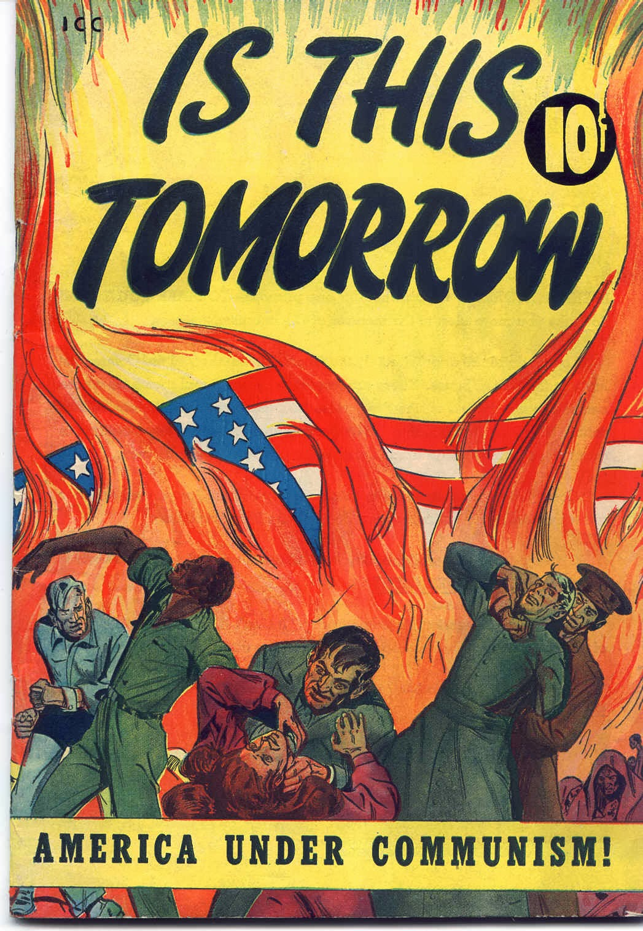
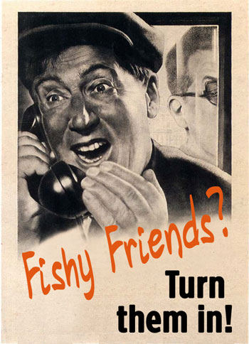
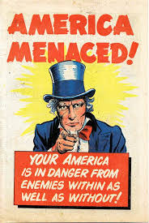
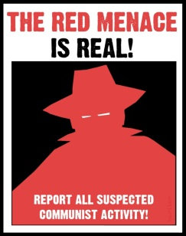
Anti-communism Propaganda

Station 4 - Questions
Red Scare and McCarthyism

Name ____________________________________________ Date ________________________ Core _________

1. Define the following terms:
- Red Scare –

- Joseph McCarthy –

- McCarthyism –

- House of Un-American Activities Committee (HUAC) –

2. What caused the Red Scare and McCarthyism to happen?

3. What or Who were some of the groups of people targeted by Joseph McCarthy?

4. What were some of the effects the Red Scare and McCarthyism had on people?

5. Do you agree or disagree with the following statement: It was necessary to take away American citizens’ constitutional rights to stop the spread of Communism and communist activities in United States. EXPLAIN YOUR ANSWER.

6. Using the examples of Anti-communist propaganda provided, Create your own Anti-communist propaganda poster.
- Your Poster Must:
  - Be in color
  - On the back of this sheet
  - An image or images that show America’s fear of Communism
  - Have a clear message to Americans on how to stop Communism or communist Activities.

