Station 2
Berlin Wall and the Iron Curtain

Name ____________________________________________ Date ________________________ Core _________

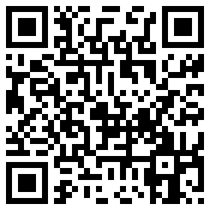
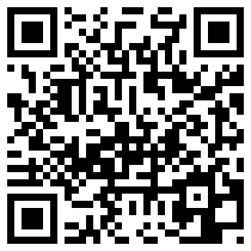
Videos
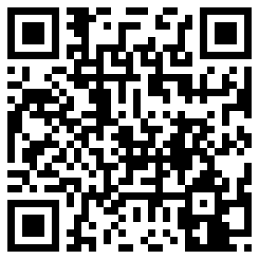

Churchill’s “Iron Curtain” Speech – 3:10 mins

Berlin Wall Deconstructed – 2:27 mins

Nov. 10, 1989 – Peter Jennings – 3:54 mins

On August 13, 1961, the Communist government of the German Democratic Republic (GDR, or East Germany) began to build a barbed wire and concrete wall between East and West Berlin. The official purpose of this Berlin Wall was to keep Western “fascists” from entering East Germany and undermining the socialist state, but it primarily served the objective of stopping mass defections (people leaving East Germany) from East to West. The Berlin Wall stood until November 9, 1989, when the head of the East German Communist Party announced that citizens of the GDR could cross the border whenever they pleased. That night, ecstatic crowds swarmed the wall. Some crossed freely into West Berlin, while others brought hammers and picks and began to chip away at the wall itself. To this day, the Berlin Wall remains one of the most powerful and enduring symbols of the Cold War.

THE BERLIN WALL: THE PARTITIONING OF BERLIN
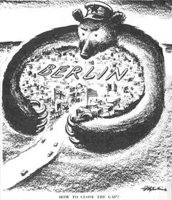
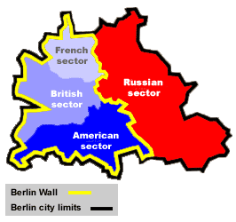
As World War II came to an end in 1945, a pair of Allied peace conferences at Yalta and Potsdam determined the fate of Germany’s territories. They split the defeated nation into four “allied occupation zones”: The eastern part of Germany went to the Soviet Union, while the western part of Germany went to the United States, Great Britain and (eventually) France. Even though Berlin was located entirely within the Soviet occupied part of Germany, the Yalta and Potsdam agreements split the city into similar sectors. The Soviets took the eastern half, while the other Allies took the western. This four-way occupation of Berlin began in June 1945.

THE BERLIN WALL: BLOCKADE AND CRISIS
The existence of West Berlin, as a capitalist city deep within communist East Germany, upset the Soviet leader Nikita Khrushchev. The Russians began maneuvering to drive the United States, Britain and France out of the city for good. In 1948, a Soviet blockade of West Berlin aimed to starve the western Allies out of the city. Instead of retreating, however, the United States and its allies supplied food and supplies to their sectors of the city from the air. This effort, known as the Berlin Airlift, lasted for more than a year and delivered more than 2.3 million tons of food, fuel and other goods to West Berlin. The Soviets called off the blockade in 1949. After a decade of relative calm, tensions flared again in 1958. For the next three years, summits, conferences and other negotiations came and went without resolution. Meanwhile, the flood of refugees continued. In the first 11 days of August, 16,000 East Germans crossed the border into West Berlin, and on August 12 some 2,400 followed—the largest number of defectors ever to leave East Germany in a single day.

THE BERLIN WALL: BUILDING THE WALL
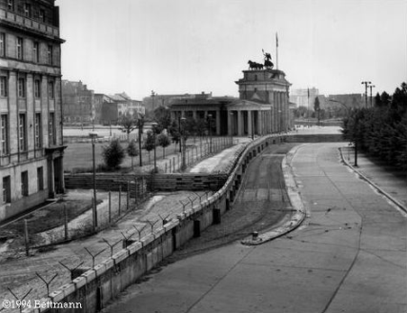
On the night of August 12, 1961, Premier Khrushchev, embarrassed by the large number of people leaving East Germany, gave the East German government permission to stop the flow of emigrants by closing its border for good. In just two weeks, the East German army, police force and volunteer construction workers had completed a makeshift barbed wire and concrete block wall–the Berlin Wall–that divided one side of the city from the other. Before the wall was built, Berliners on both sides of the city could move around fairly freely: They crossed the East-West border to work, to shop, to go to the theater and the movies. Trains and subway lines carried passengers back and forth. After the wall was built, it became impossible to get from East to West Berlin except through a military checkpoint. At each of the checkpoints, East German soldiers screened diplomats and other officials before they were allowed to enter or leave. Except under special circumstances, travelers from East and West Berlin were rarely allowed across the border.

THE BERLIN WALL: 1961-1989
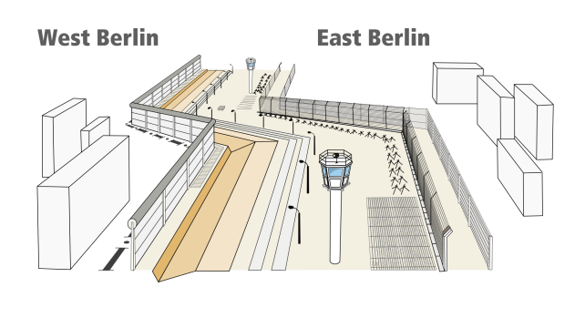
The construction of the Berlin Wall did stop the flood of refugees from East to West, and it did defuse the crisis over Berlin. Over time, East German officials replaced the makeshift wall with one that was sturdier and more difficult to scale. A 12-foot-tall, 4-foot-wide mass of reinforced concrete was topped with an enormous pipe that made climbing over nearly impossible. Behind the wall on the East German side was a so-called “Death Strip”: a gauntlet of soft sand (to show footprints), floodlights, vicious dogs, trip-wire machine guns and patrolling soldiers with orders to shoot escapees on sight. In all, at least 171 people were killed trying to get over, under or around the Berlin Wall. Escape from East Germany was not impossible, however: From 1961 until the wall came down in 1989, more than 5,000 East Germans (including some 600 border guards) managed to cross the border by jumping out of windows adjacent to the wall, climbing over the barbed wire, flying in hot air balloons, crawling through the sewers and driving through unfortified parts of the wall at high speeds.

THE BERLIN WALL: THE FALL OF THE WALL
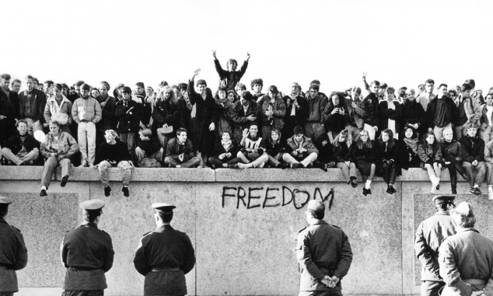
On November 9, 1989, as the Cold War began to thaw across Eastern Europe, the spokesman for East Berlin’s Communist Party announced a change in his city’s relations with the West. Starting at midnight that day, he said, citizens of the GDR were free to cross the country’s borders. More than 2 million people from East Berlin visited West Berlin that weekend to participate in a celebrations. People used hammers and picks to knock away chunks of the wall, while cranes and bulldozers pulled down section after section. Soon the wall was gone and Berlin was united for the first time since 1945. “Only today,” one Berliner spray-painted on a piece of the wall, “is the war really over.” The reunification of East and West Germany was made official on October 3, 1990, almost one year after the fall of the Berlin Wall.

What Is the 'Iron Curtain?'
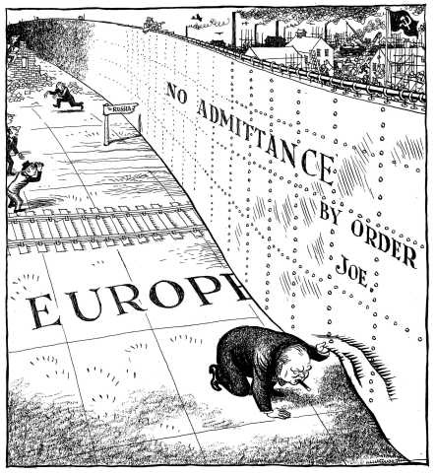
The term 'Iron Curtain' usually refers to an imaginary barrier that symbolized the differences in beliefs and physical boundary dividing Europe into two separate areas from the end of World War II in 1945 until the end of the Cold War in 1991. Winston Churchill, who popularized the term “Iron Curtain”, gave it its current meaning as a reference to the region of Soviet-backed states. In 1946, while visiting the United States, Churchill gave a famous speech in which he said, 'An iron curtain has descended across the continent.' The term has propagandistic value, and usually implies the brute strength and oppression that characterized communist government in Eastern Europe. The term 'Iron Curtain' is sometimes used synonymously with the Eastern Bloc, Communist Bloc, or the Warsaw Pact. Among the most notable countries 'behind the Iron Curtain' were the Soviet Union, East Germany, Poland, Romania, Czechoslovakia, Hungary, Albania, and Bulgaria.

The Origins of the 'Iron Curtain'
If you remember from World War II, the Soviet Union attacked through Eastern Europe in order to invade Nazi Germany. When the war ended in 1945, Soviet troops occupied countries like Poland, Romania, Czechoslovakia, East Germany, and others. The Soviets, seeking a buffer zone of friendly states, between Germany and the Soviet Union, moved quickly to establish communist puppet governments in occupied countries. A puppet government is a government that is perceived to be or actually is dependent on or influence by an outside power. In this case, countries in the Iron Curtain were heavily influence and controlled by the Soviet Union. The Allies attempted to stop the expansion of the Soviet Union at the Yalta and Potsdam Conferences, but Joseph Stalin failed to keep his promises and helped set up communist government in the Soviet controlled areas after World War II. Unwilling to risk outright war, there was little the Western democracies could do except stand by and watch as Eastern Europe fell to communism.

Lesson Summary
Let's review. The term 'Iron Curtain' refers to the collection of communist governments in Eastern Europe that emerged in post-war Europe. The term is often used synonymously with Eastern Bloc, Communist Bloc, and the Warsaw Pact. The British Prime Minister Winston Churchill who popularized the term, and gave the “Iron Curtain” its current meaning, he did so in 1946 in his 'Iron Curtain' speech. The countries behind the 'Iron Curtain' were the Soviet Union, East Germany, Poland, Romania, Czechoslovakia, Hungary, Albania, Bulgaria, and others.
Despite his pledges at the Yalta and Potsdam Conferences, Soviet dictator Joseph Stalin worked behind the scenes to ensure that communist puppet governments were installed. In Germany, the 'Iron Curtain' took a physical form in the Berlin Wall. The wall divided East and West Germany, preventing East German citizens from escaping to freedom in democratic West Germany. The Revolutions of 1989 began in Poland, and eventually led to the collapse of the Soviet Union, thus bringing about the fall of the 'Iron Curtain.

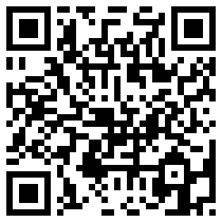
Sources:

http://www.history.com/topics/cold-war/berlin-wall

http://education-portal.com/academy/lesson/post-war-soviet-union-

eastern-europe-the-descent-of-the-iron-curtain.html

Kennedy and the Jelly Doughnut – 1:59 mins

Additional Video:

Station 2 – Questions
Berlin Wall and the Iron Curtain

Name ____________________________________________ Date ________________________ Core _________

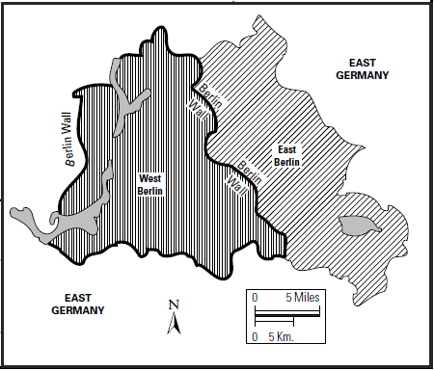
1. Color the map of Germany in 1961, using the map in the reading selection.
- Red – for the COMMUNIST side of Germany
- Blue – for the DEMOCRATIC side of Germany
- Yellow – for the Berlin Wall

2. Using the map provided and the reading, which countries were part of the “Iron Curtain?”

3. Using the map provided and the reading, which countries were NOT part of the “Iron Curtain?”

4. Define the following terms, in your own words”
- Berlin Wall –

- Iron Curtain –

- Berlin Blockade –

- Berlin Airlift -

5. Describe the Partition, or separation of Berlin. Who controls what part?

6. How is the Iron Curtain similar to the Berlin Wall?

7. Why did the Soviet leader, Nikita Khrushchev want to build the Berlin Wall?

8. Describe the construction and layout of the Berlin Wall? For example: How tall was the wall and what was used to separate East Berlin from West Berlin?

9. What were some of the effects of the Berlin Wall on the people who lived in Berlin?

10. How do you think the Berlin people felt when the Berlin Wall came down? (USE MORE THAN ONE WORD)

11. What are some other names that the Iron Curtain is sometimes known as?

12. Circle True or False: The Berlin Wall was a permanent, physical wall that separated Berlin during the Cold War.

TRUE FALSE

13. Circle True or False: The Iron Curtain was a fake, symbolic, imaginary wall used to describe the differences between Western Europe and Eastern Europe during the Cold War.

TRUE FALSE

