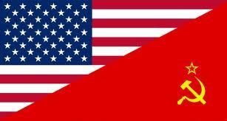
Station 1
Differences in Beliefs: United States vs. Soviet Union

Name ____________________________________________ Date ________________________ Core _________

Videos:

Cold War Timeline - 8:32 mins

Start of the Cold War – brief summary – 4:59 mins

Chilling Facts about the Cold War – 1:47 mins

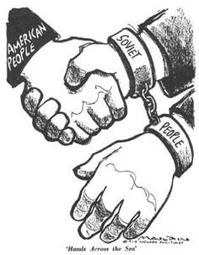
The Emergence of the Two Super Powers and the Roots of the Cold War
If you recall your World War II history, the United States and the Soviet Union were allies during the war. Together, these nations and others brought about the downfall of Hitler's Third Reich. When the war ended in 1945, these two countries emerged as world super powers. They were it: the two most powerful states in the world. When the war ended, the two super powers had very different ideas of how Europe should be restructured. Herein lays the roots of the Cold War.
The Cold War, of course, was a prolonged period of tension between the United States and the Soviet Union, lasting between the end of World War II and the fall of communism. While the Cold War spawned regional 'hot wars,' like the Korean War and the Vietnam War, the Cold War was characterized by threats, tension, and competition -- not physical combat. Basically, between 1945 and 1991, the United States and the Soviet Union did not like each other very much.

Summary
The U.S. President Roosevelt died in 1945. He was replaced by Truman who was strongly anti-Communist and, as the war came to an end, the relationship between America and Russia fell apart, especially after the Potsdam Conference. In 1945, Harry S Truman became president of the USA, determined to confront Communism. He is reported to have told his advisers: “The Russians only understand one language - how many armies have you got? I'm tired of babying the Soviets.”
But this was not the only cause of trouble. Historians believed that the wartime alliance between the Soviet Union and America was also wrecked by the huge differences between the two countries in:
- Politics - America was capitalist, Soviet Union was communist.
- Lifestyle - America had freedom and a two-party democracy; Soviet Union had secret police and a one-party state.
- Aims - America wanted Germany to recover as a trading partner; Soviet Union wanted to weaken Germany and create a buffer zone of friendly states around Russia.
The collapse of the wartime alliance led to a Cold War between the two superpowers.
America and Soviet Union Compared
America | Soviet Union
1. The richest country in the world. | 1. The biggest country in the world.
2. A democracy with free elections, led by an elected president. | 2. A one-party state led by a dictator. There were elections, but you could only vote for the Communist Party.
3. Freedom of speech and belief. | 3. State control: censorship, secret police, terror and purges.
4. Capitalism - private ownership and the right to make money. | 4. Communism - state ownership of the means of production, and the belief that wealth should be shared.
5. Led by Truman, who believed that Communism was evil. | 5. Led by Stalin, who believed that capitalism was evil.
6. Had the atomic bomb- but was scared of Russia's conventional army. | 6. Had the biggest army in the world - but was angry that Truman had not warned that he was going to drop the atomic bomb.
7. Feared the spread of communism throughout the world. | 7. Was angry because America and Britain had invaded Russia in 1918-19 to try to destroy communism.
8. Angry about the Nazi-Soviet Pact that was a major factor in starting the Second World War. | 8. Believed that America and Britain had delayed opening the second front (attacking France) to let Germany and Russia destroy each other on the eastern front.
9. Wanted reconstruction - to make Germany a prosperous democracy and a trading partner. | 9. Wanted to wreck Germany, take hug reparations for the damage done during the war, and set up a buffer of friendly states around Russia to prevent another invasion in the future.

Sources:
http://www.bbc.co.uk/schools/gcsebitesize/history/mwh/ir2/
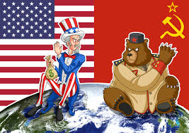
http://education-portal.com/

Station 1 – Questions
Differences in Beliefs: United States vs. Soviet Union

Name ____________________________________________ Date ________________________ Core _________

1. Define the Cold War in your own words.

2. How can the Cold War be characterized?

3. What are the TWO major causes of the Cold War?

4. There were significant differences between the Soviet Union and the United States in politics, lifestyle and…
A. Aims
B. Power
C. Food

5. While U.S. was the richest country in the world, the Soviet Union was the…
A. Poorest
B. Cleverest
C. Biggest

6. While the U.S. was a democracy, the Soviet Union was a...
A. Disarmament
B. Dictatorship
C. Department

7. While U.S. was capitalist, the Soviet Union was…
A. Communist
B. Controlled by the State
C. A one-party state

8. At the very beginning of the Cold War, America had the atomic bomb, the Soviet Union had…

A. … the biggest converted army in the world.
B. … the biggest conventional army in the world
C…. the biggest convection army in the world

9. While the U.S. wanted to reconstruct Germany, the Soviet Union wanted…
A. Respirations
B. Recreations
C. Reparations

10. Where the U.S. feared the spread of Soviet power, the Soviet Union wanted to create…

A. … a buffet zone of friendly states around Russia.
B. … a baffle zone of friendly states around Russia.
C. … a buffer zone of friendly states around Russia

